Deep Learning is the most exciting and powerful branch of Machine Learning. Deep Learning models can be used for a variety of complex tasks:

* Artificial Neural Networks for Regression and Classification
* Convolutional Neural Networks for Computer Vision
* Recurrent Neural Networks for Time Series Analysis
* Self-Organizing Maps for Feature Extraction
* Deep Boltzmann Machines for Recommendation Systems
* Auto Encoders for Recommendation Systems

In this part, you will understand and learn how to implement the following Deep Learning models:

1. Artificial Neural Networks for a Business Problem
2. Convolutional Neural Networks for a Computer Vision task

Enjoy Machine Learning!



There were no technology (Storage, processing) and data in old days

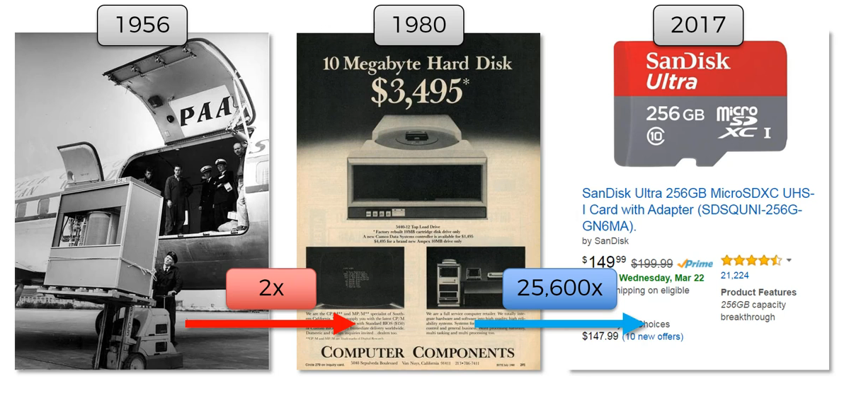

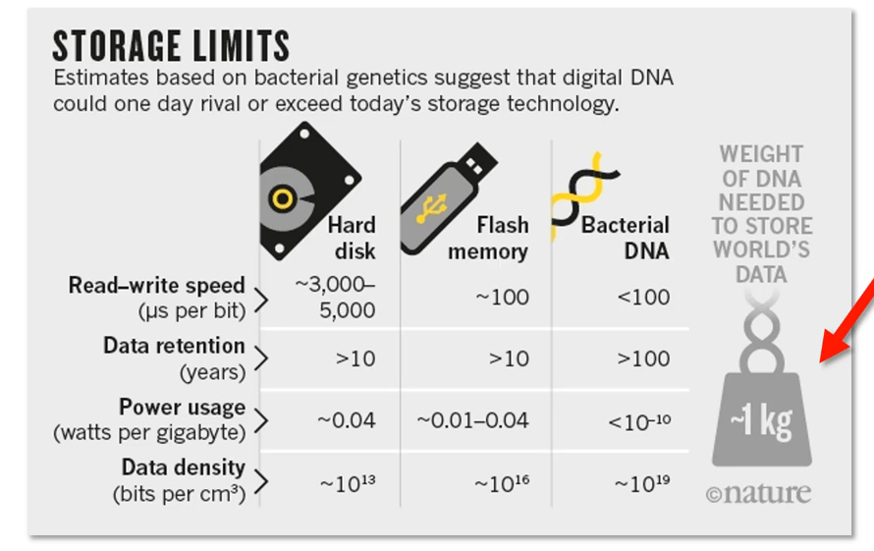

**In this generation we have data and technology.**

**Deep-Learning:**

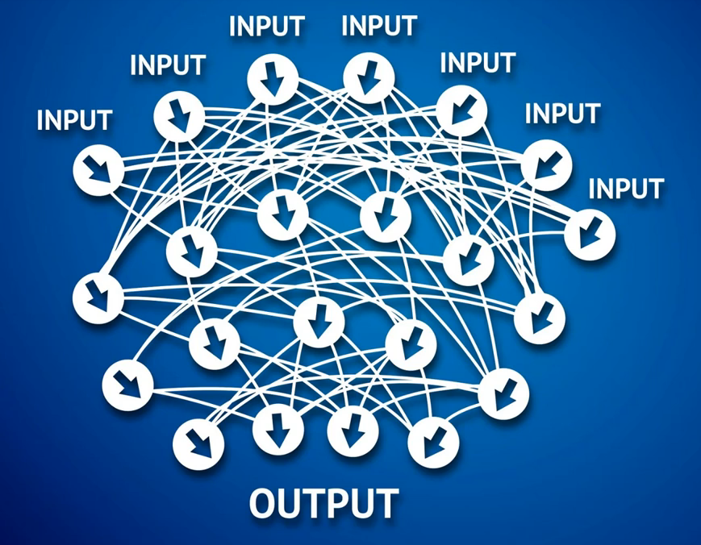

**Neuron in human brain,100 billion**

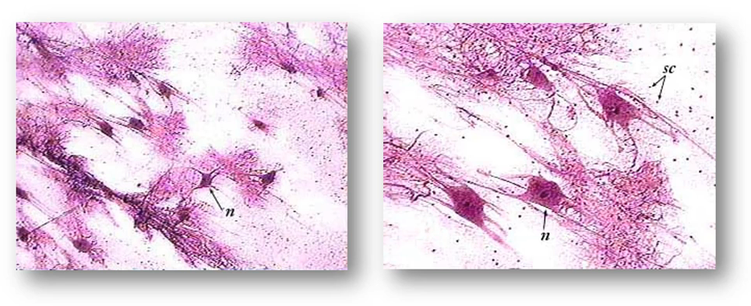

**We will use the working process of brain in deep learning,**

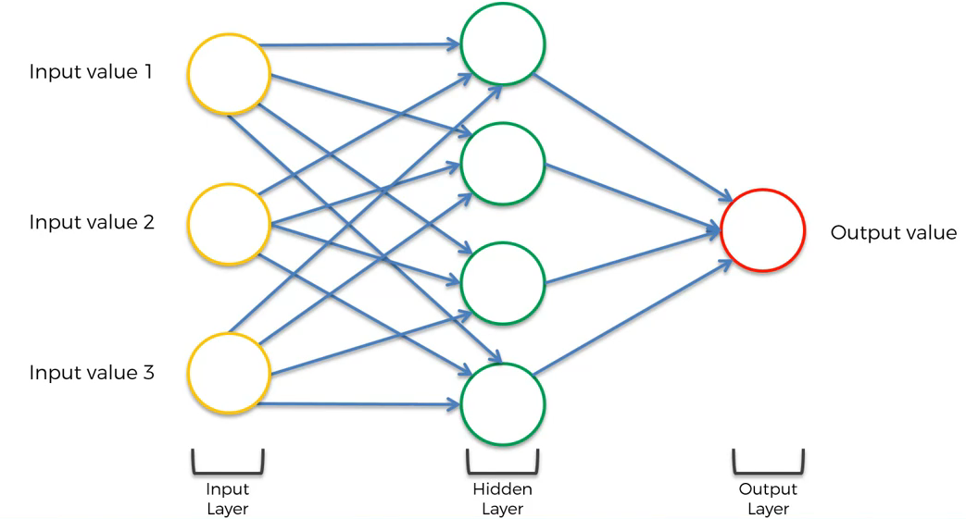

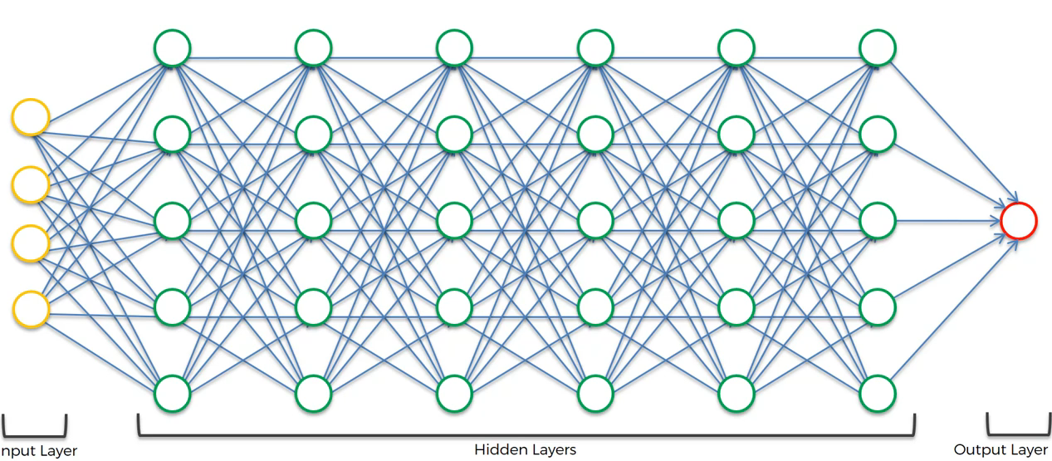



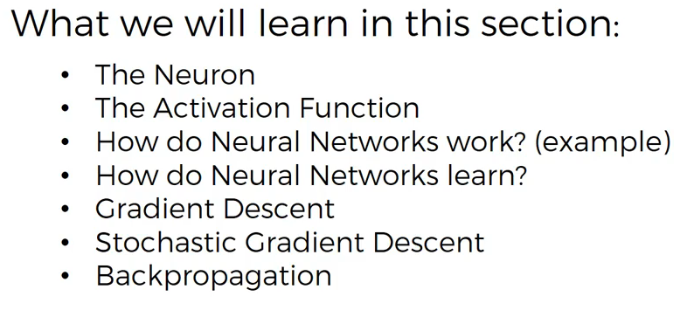



**We will recreate the working of brain using Artificial Neural Network**

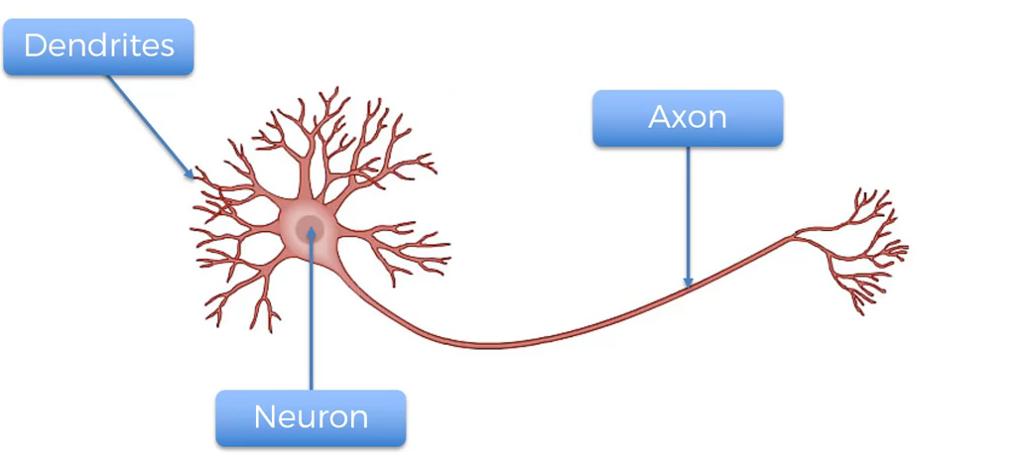

**Receiver🡪Dendrites**

**Sender🡪 Axon**

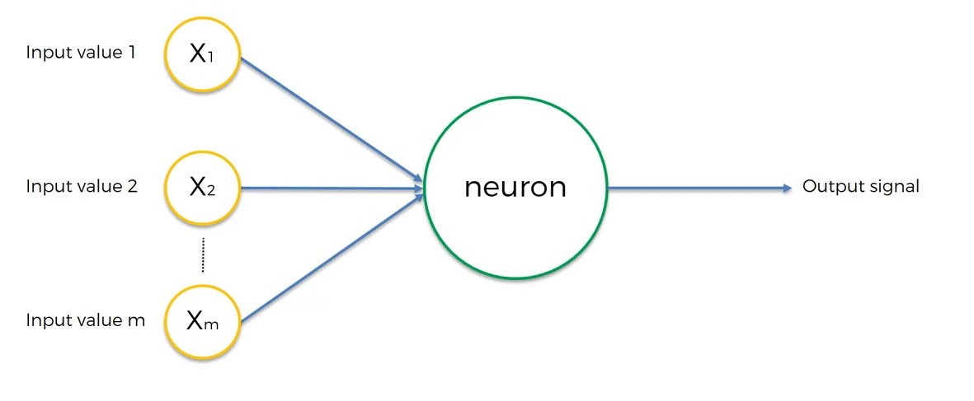

**Yellow🡪input layer**

**Green🡪Hidden Layer**

**Red🡪Output layer**

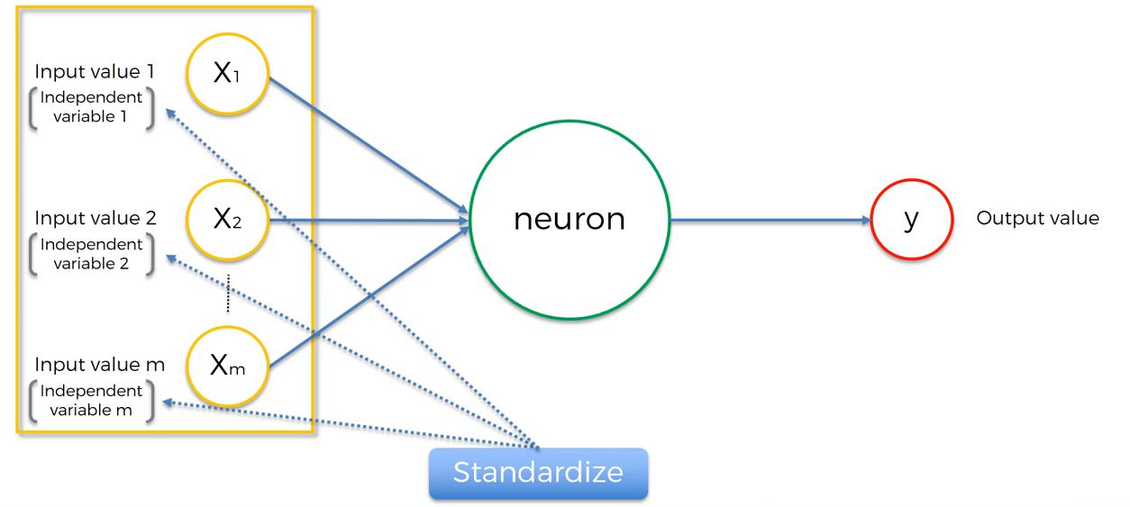

[**http://yann.lecun.com/exdb/publis/pdf/lecun-98b.pdf**](http://yann.lecun.com/exdb/publis/pdf/lecun-98b.pdf)

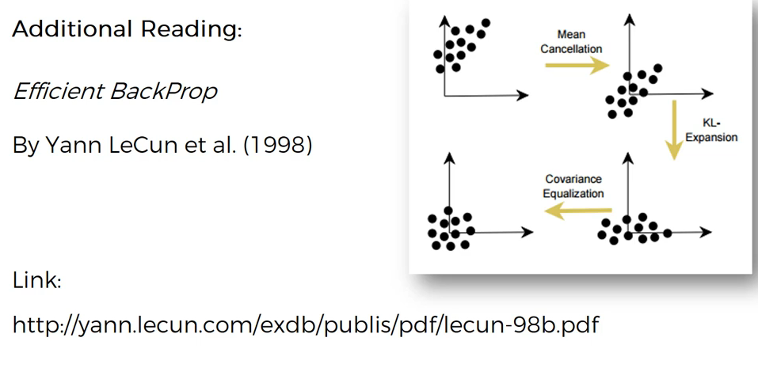

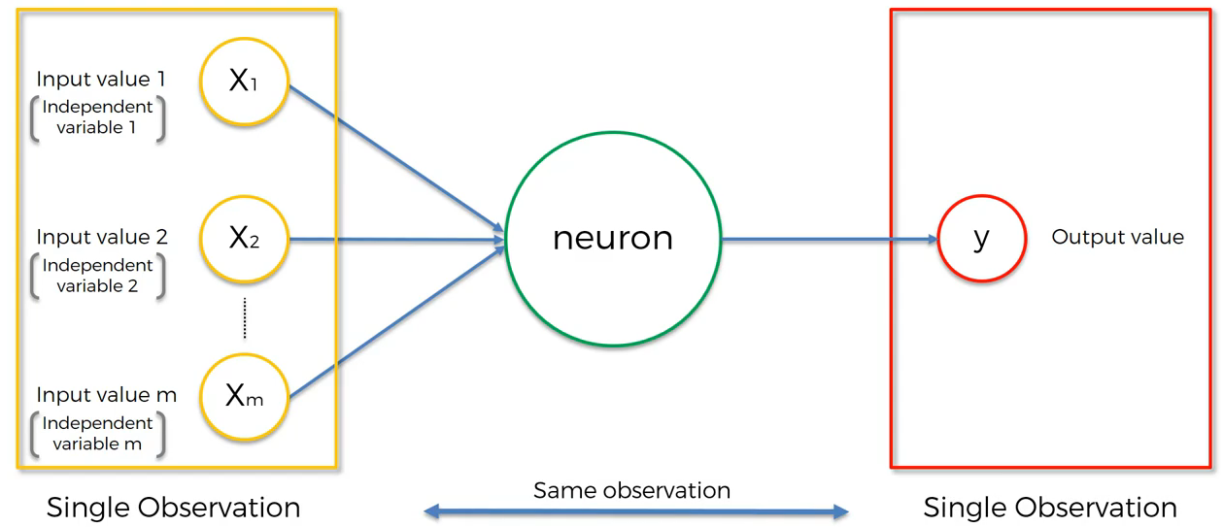

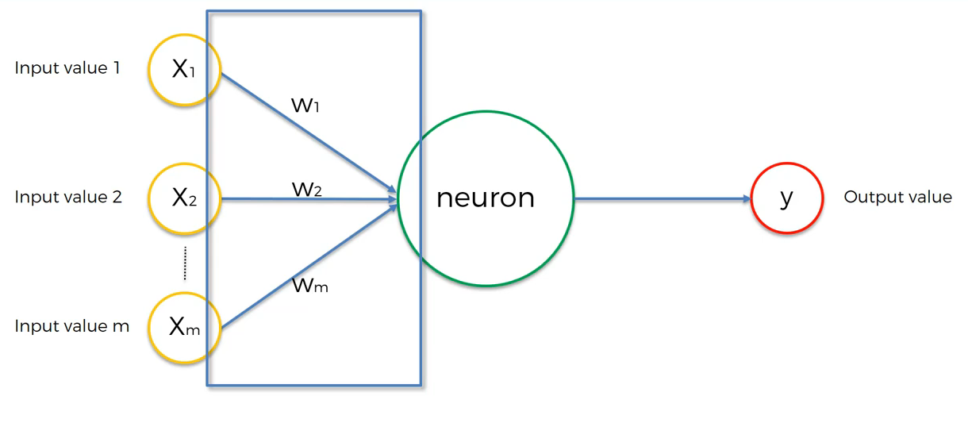

**Weights will be calculated**

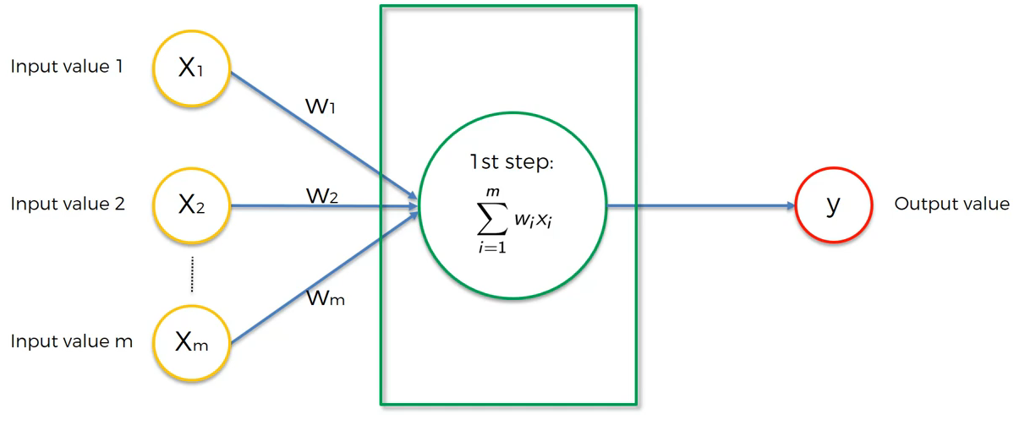

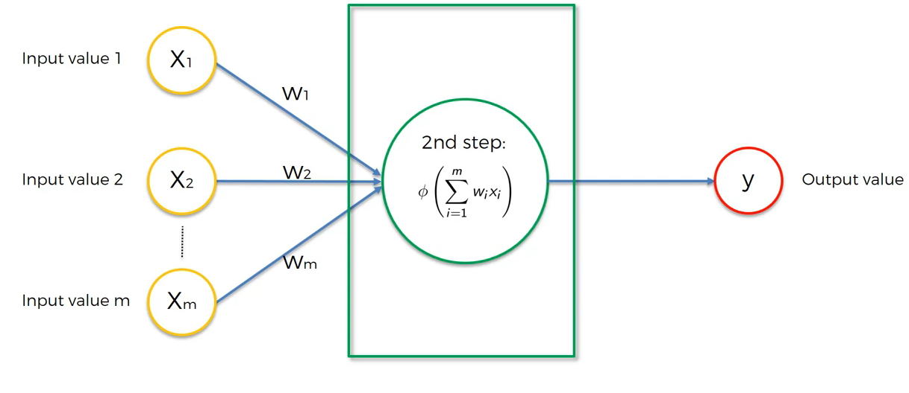

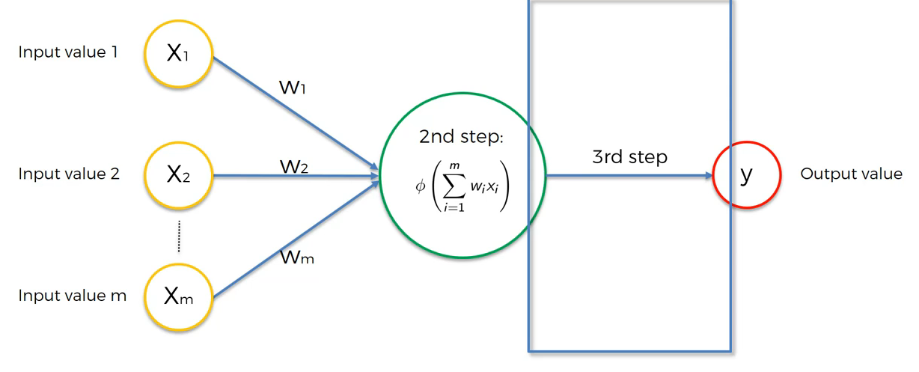

**The Activation Function:**

**Step 3 is called as activation function**



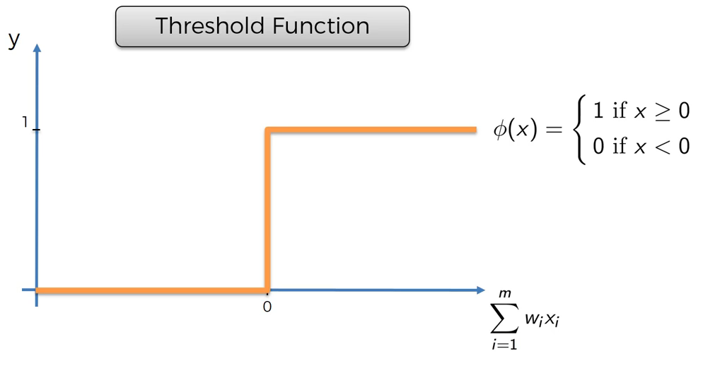

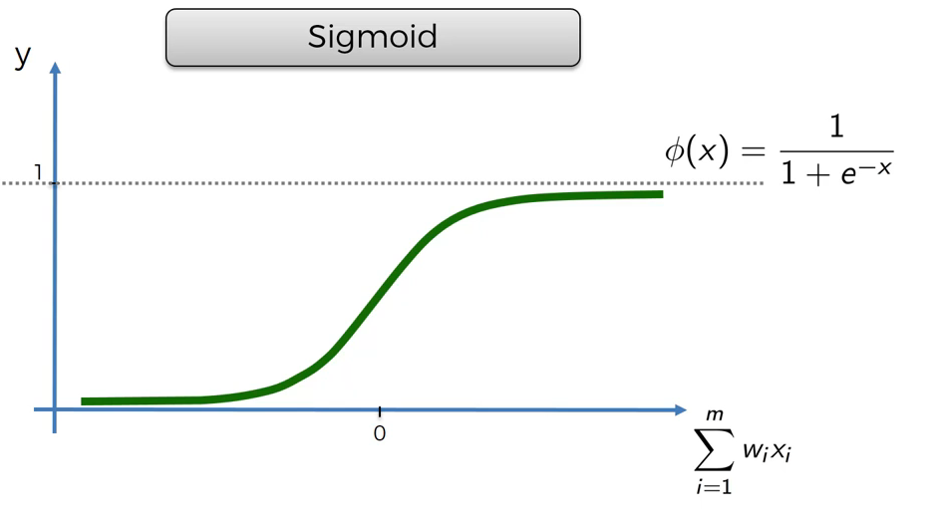

**Curve is smooth, to predict probability. Similar to logistic regression.**

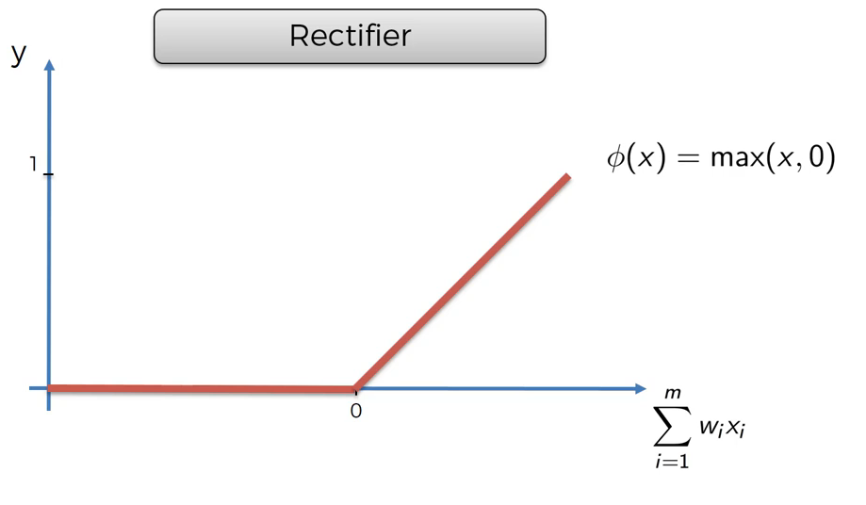

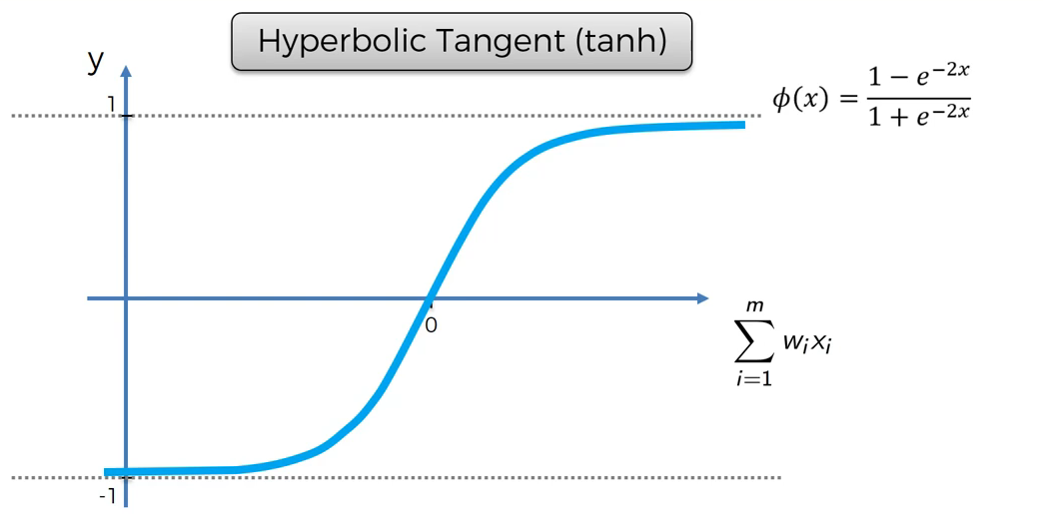

**Similar to Sigmoid, but it ranges from -1 to 1**

**Reference:**

[**http://proceedings.mlr.press/v15/glorot11a/glorot11a.pdf**](http://proceedings.mlr.press/v15/glorot11a/glorot11a.pdf)

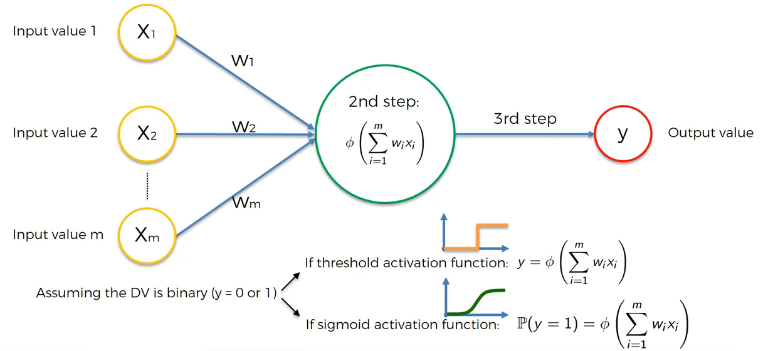

**Working:**

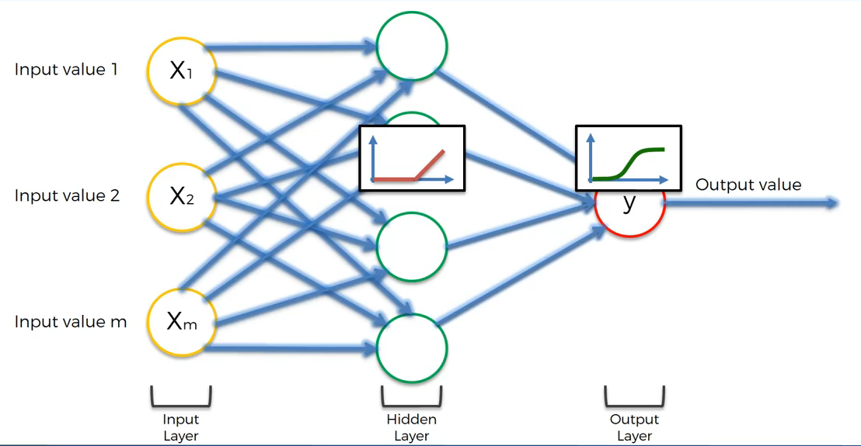

**Hidden🡪Rectifier**

**Output🡪 Sigmoid, to predict the probability.**



**Example: To predict the price of the property.**

**Without hidden layer, regression algorithm**

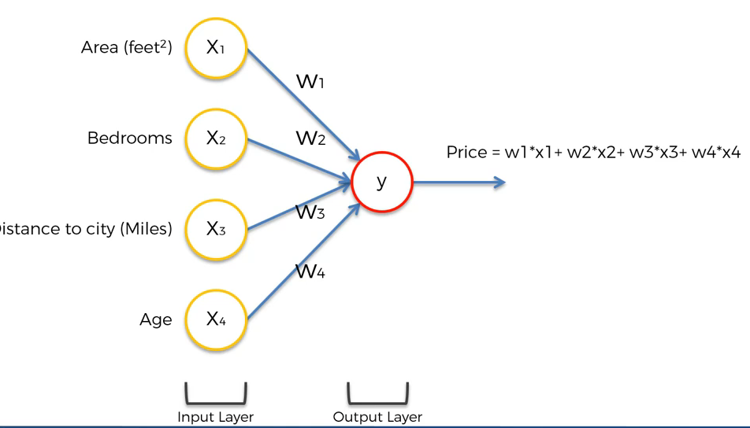

**Hidden layer will give extra power,**

**Neuron 1: Focus on Area and Distance**

**Neuron 3: Focus on Area, Bedroom and Distance**

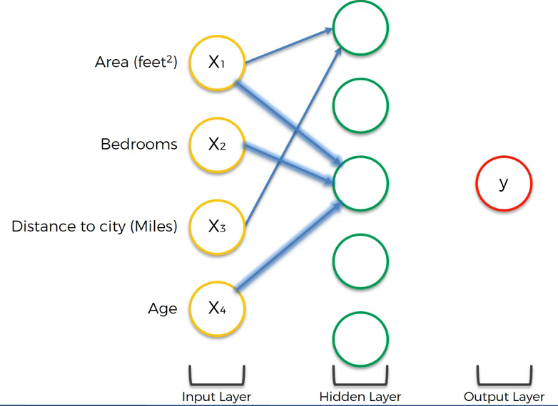

**Neuron 5: Focus on Age (Eg: property over 100 years it is historic and rate is also high)**

**Neuron 2: Bedrooms, Distance**

**Neuron 4: All the factors**

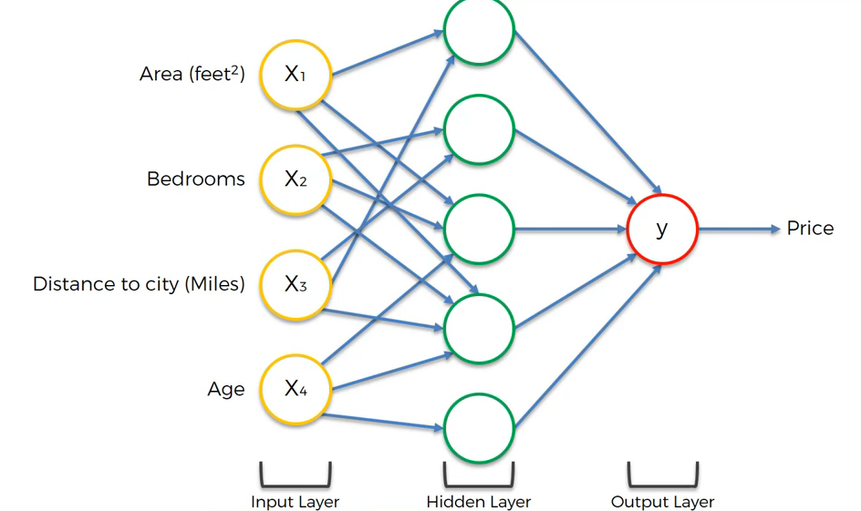



**🡪Unsupervised Learning**

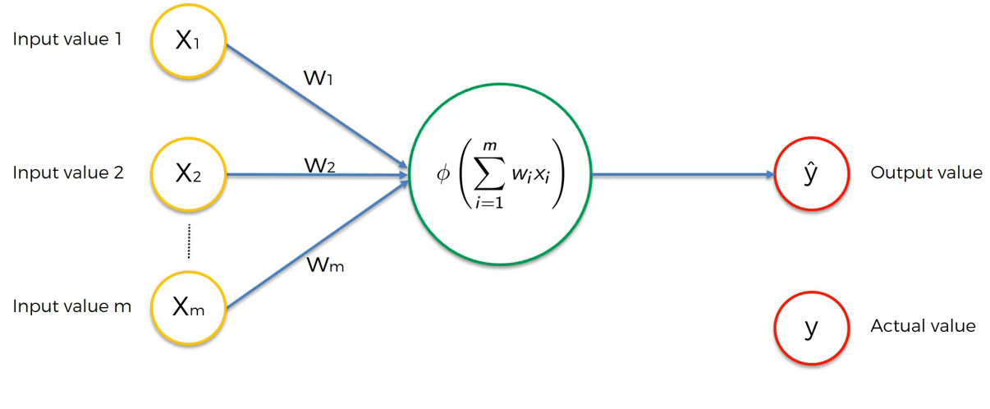

**Y^ is the predicted value**

**Y is the actual value.**

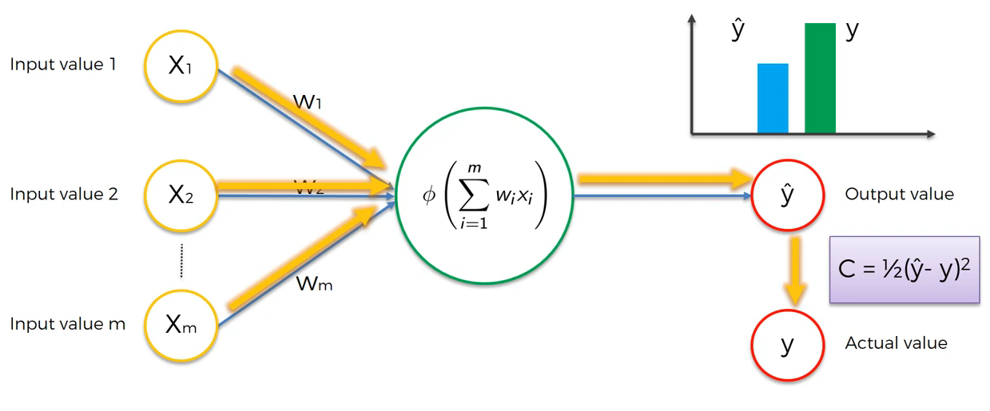

**Y^ and Y are compared with Cost function (C) will give us the error.**

**Once the comparison is done, it will be sent to neural network.**

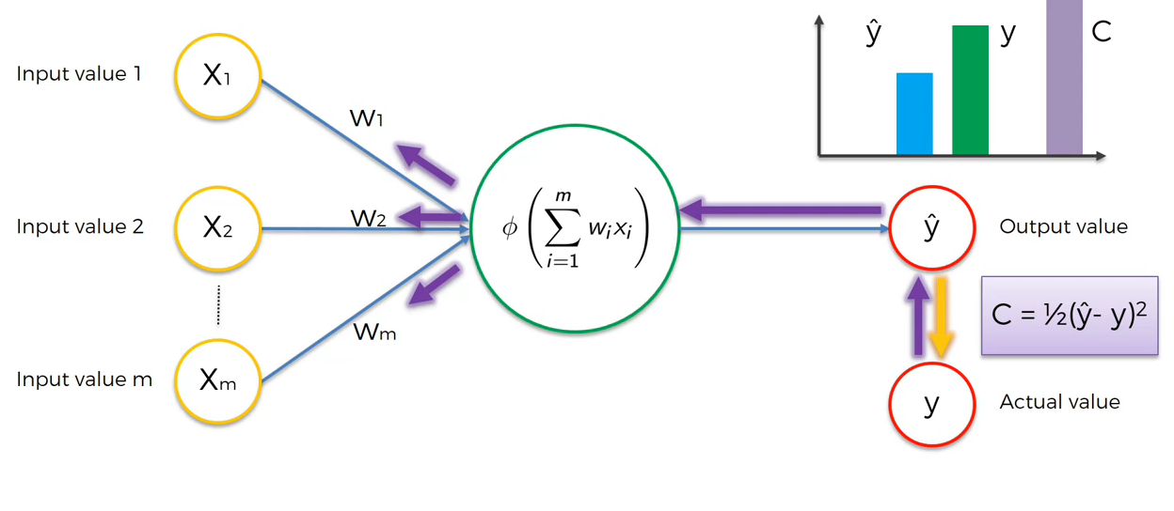

**Round 1:**

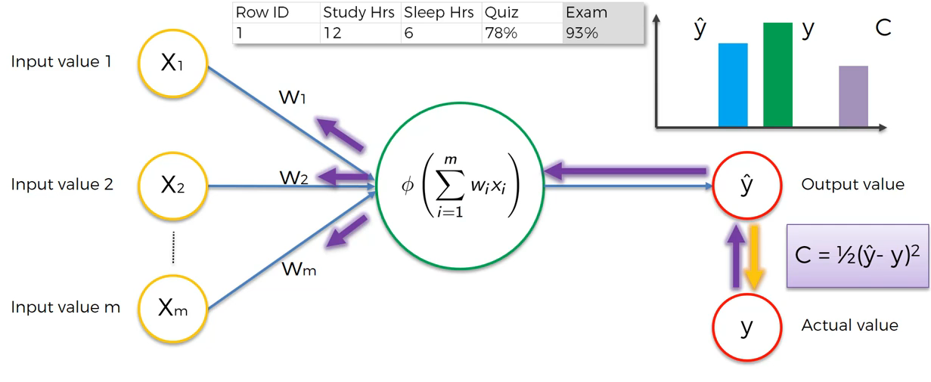

**Our aim is minimum cost function (error) and the error rate is sent to the neuron so that it will get updated and correct itself.**

**Round 2;**

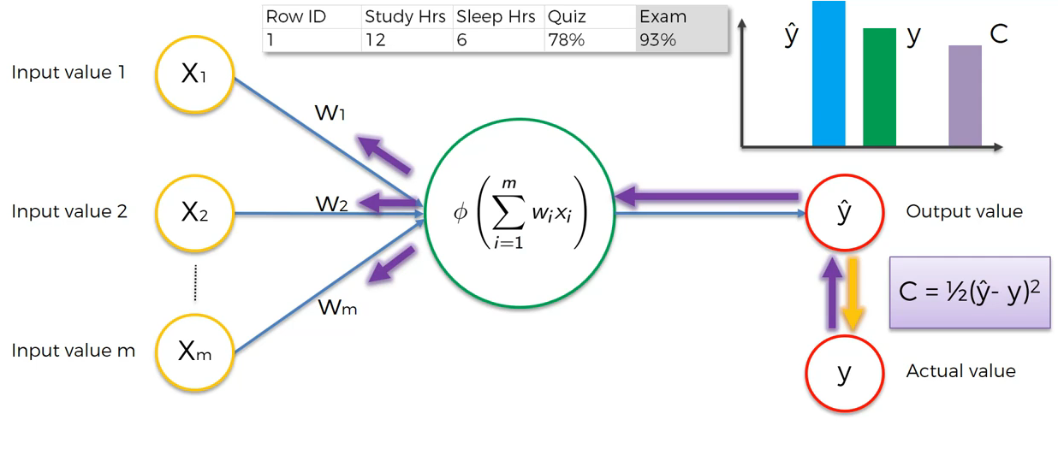

**Round 3: C value is comparatively less**

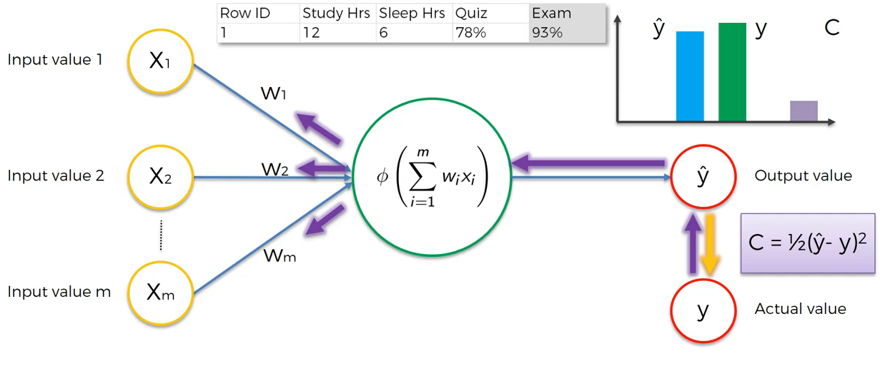

**Round 4: C value is ‘0**’

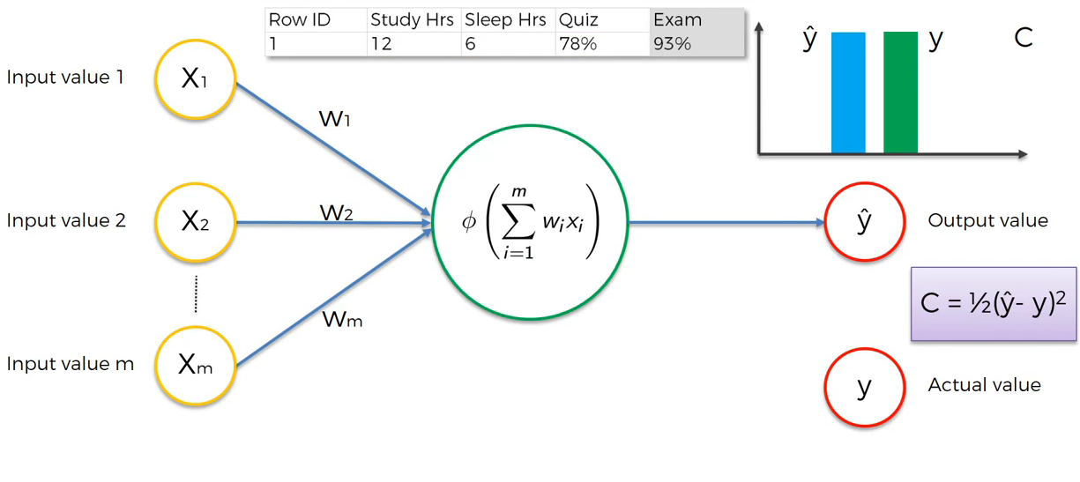

**For multiple row,**

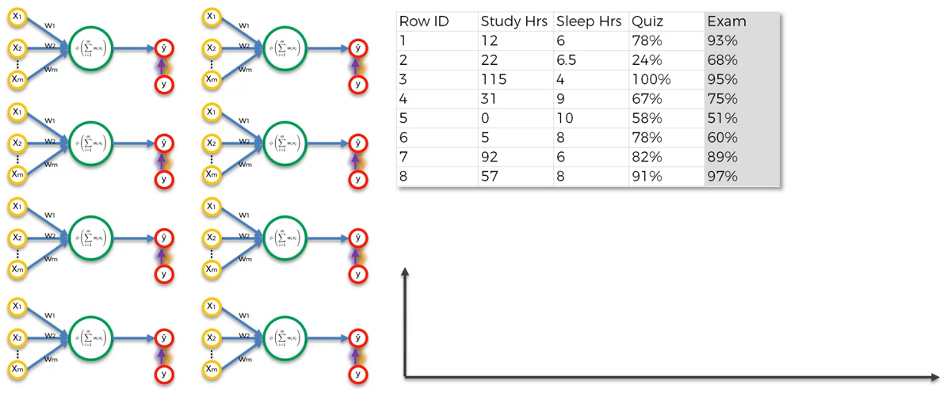

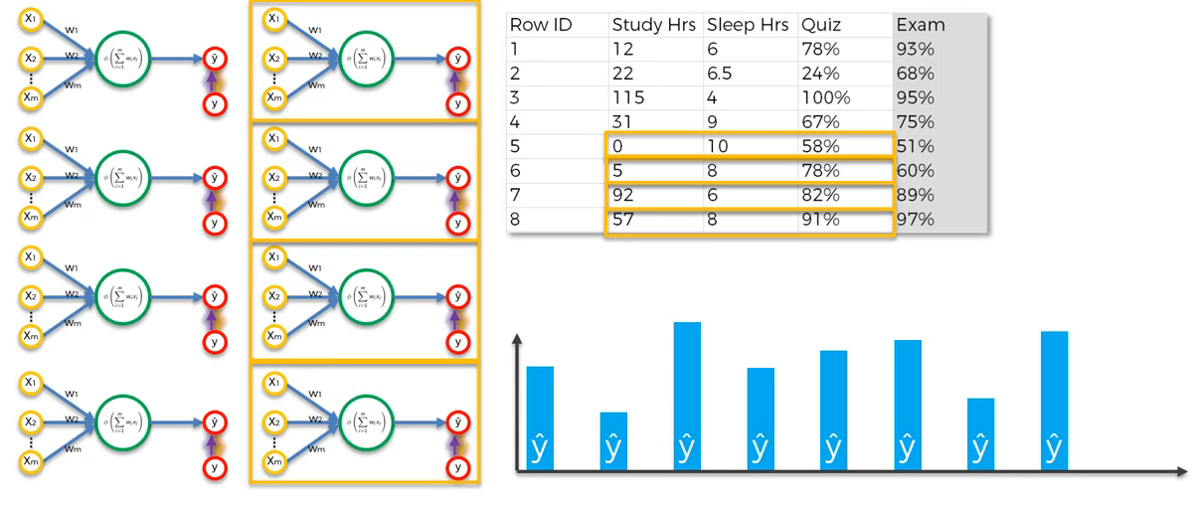

**Calculate C, compare with y**

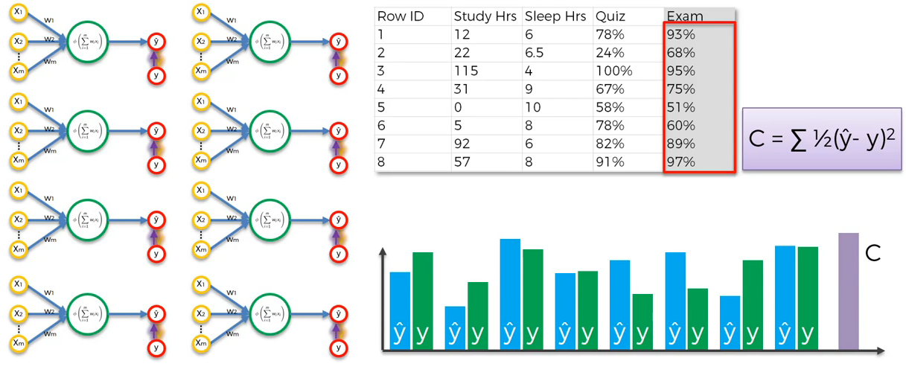

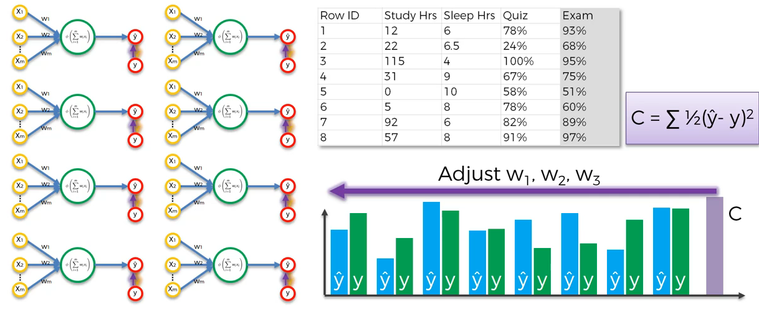

**Our goal is to reduce ‘C’ to minimum. This process is called Backward Propagation**

**Reference:**

[**https://stats.stackexchange.com/questions/154879/a-list-of-cost-functions-used-in-neural-networks-alongside-applications**](https://stats.stackexchange.com/questions/154879/a-list-of-cost-functions-used-in-neural-networks-alongside-applications)

**Convolution Neural Networks:**

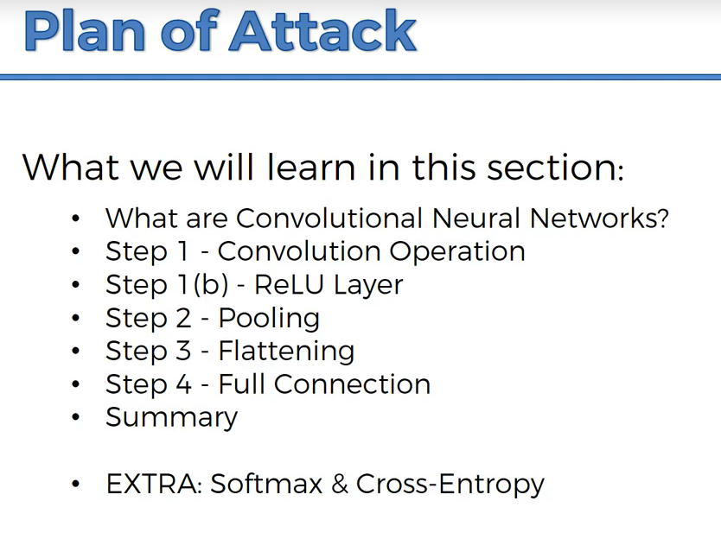

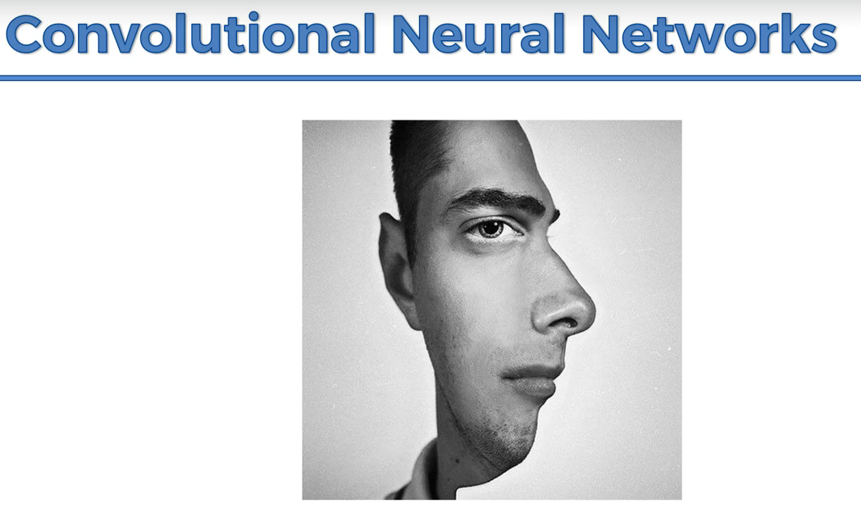

Brain will pick the features based on which the brain classifies the image.

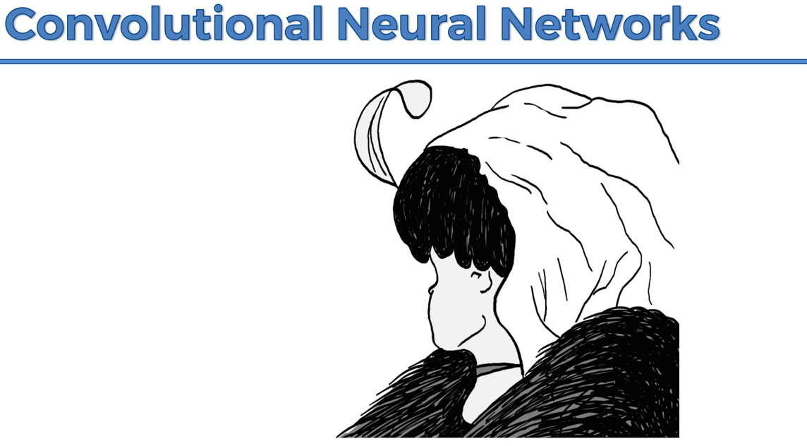

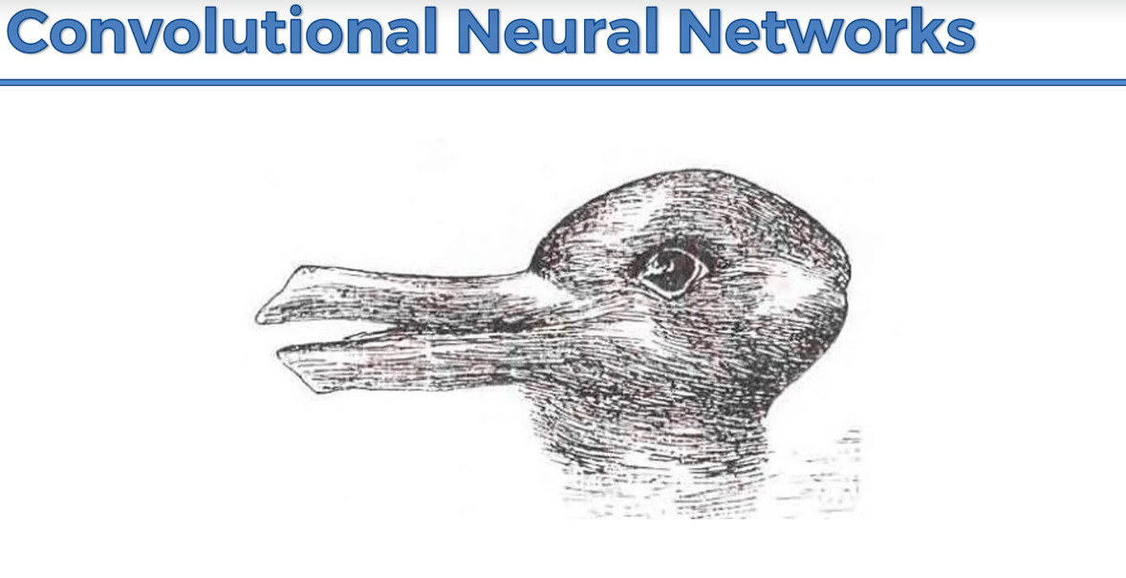

Brain is trying to understand the image by switching the eye in the image.

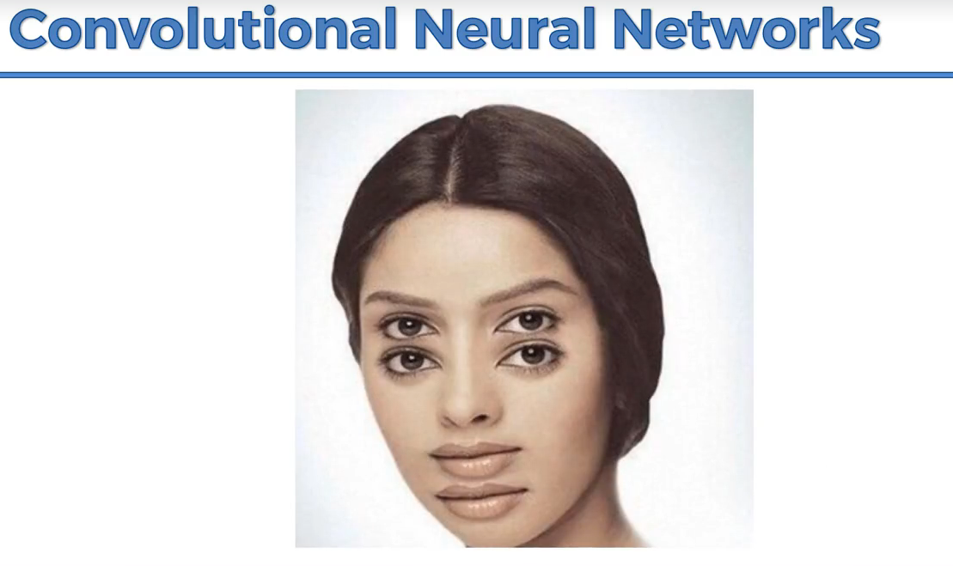

CNN will process the images and predict the image.

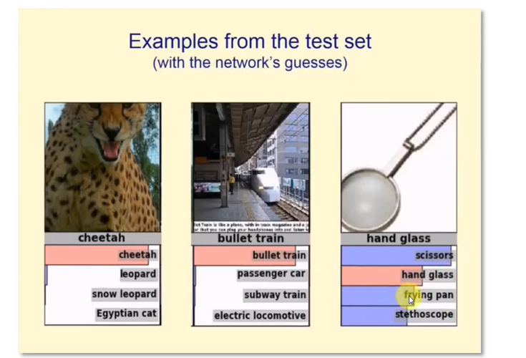

**Working of CNN:**

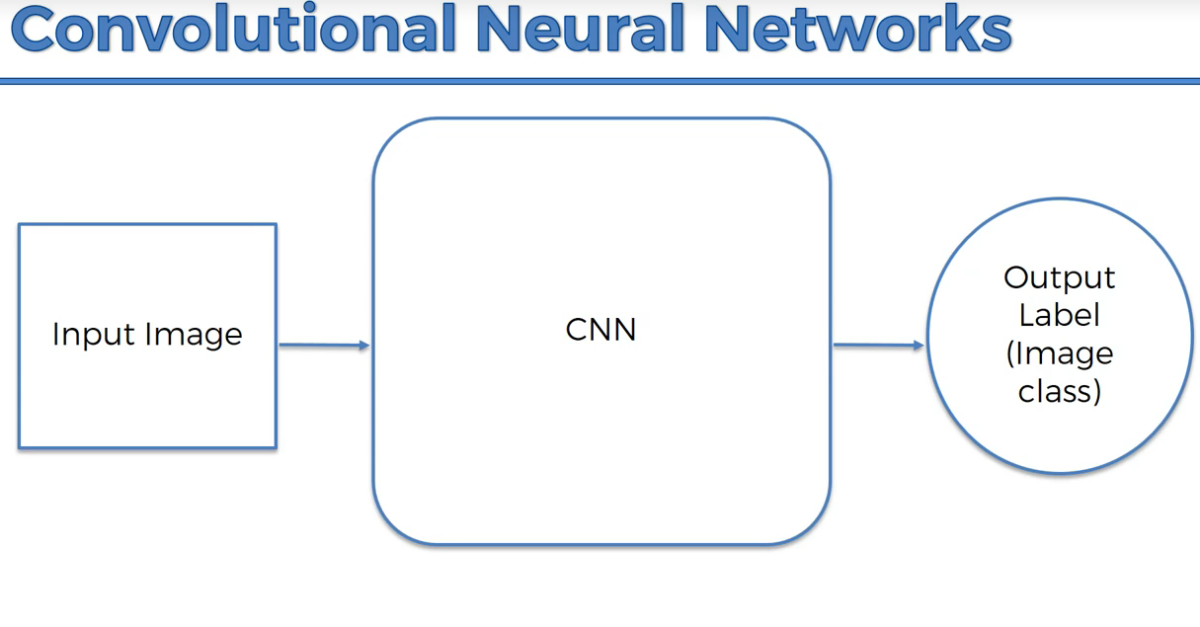

CNN can recognize emotions,

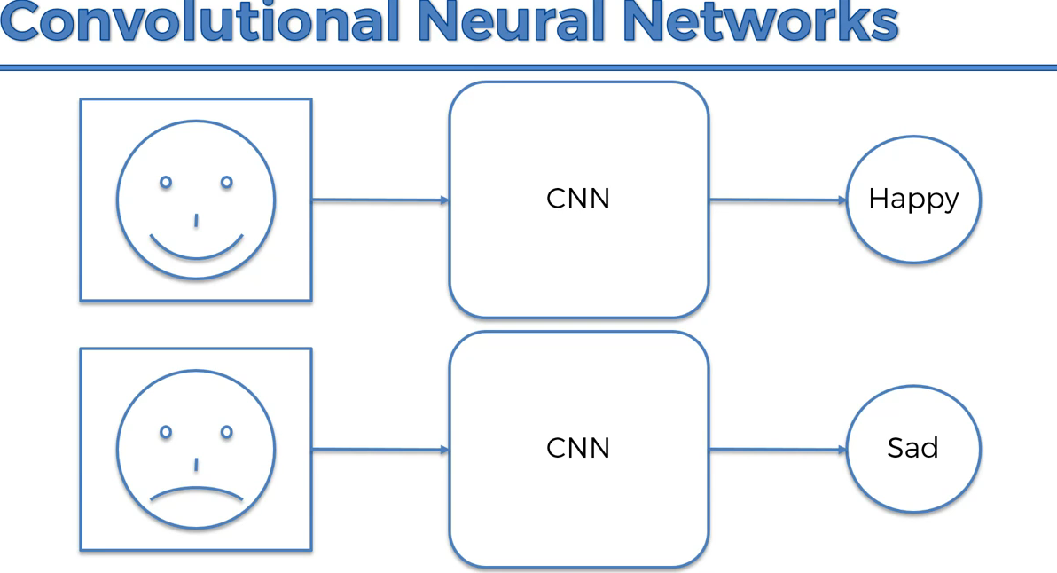

Sometimes if the image is not clear, CNN accuracy can reduce like human brain

**Drill down of CNN working:**

Colored image🡪3d(R,G,B)

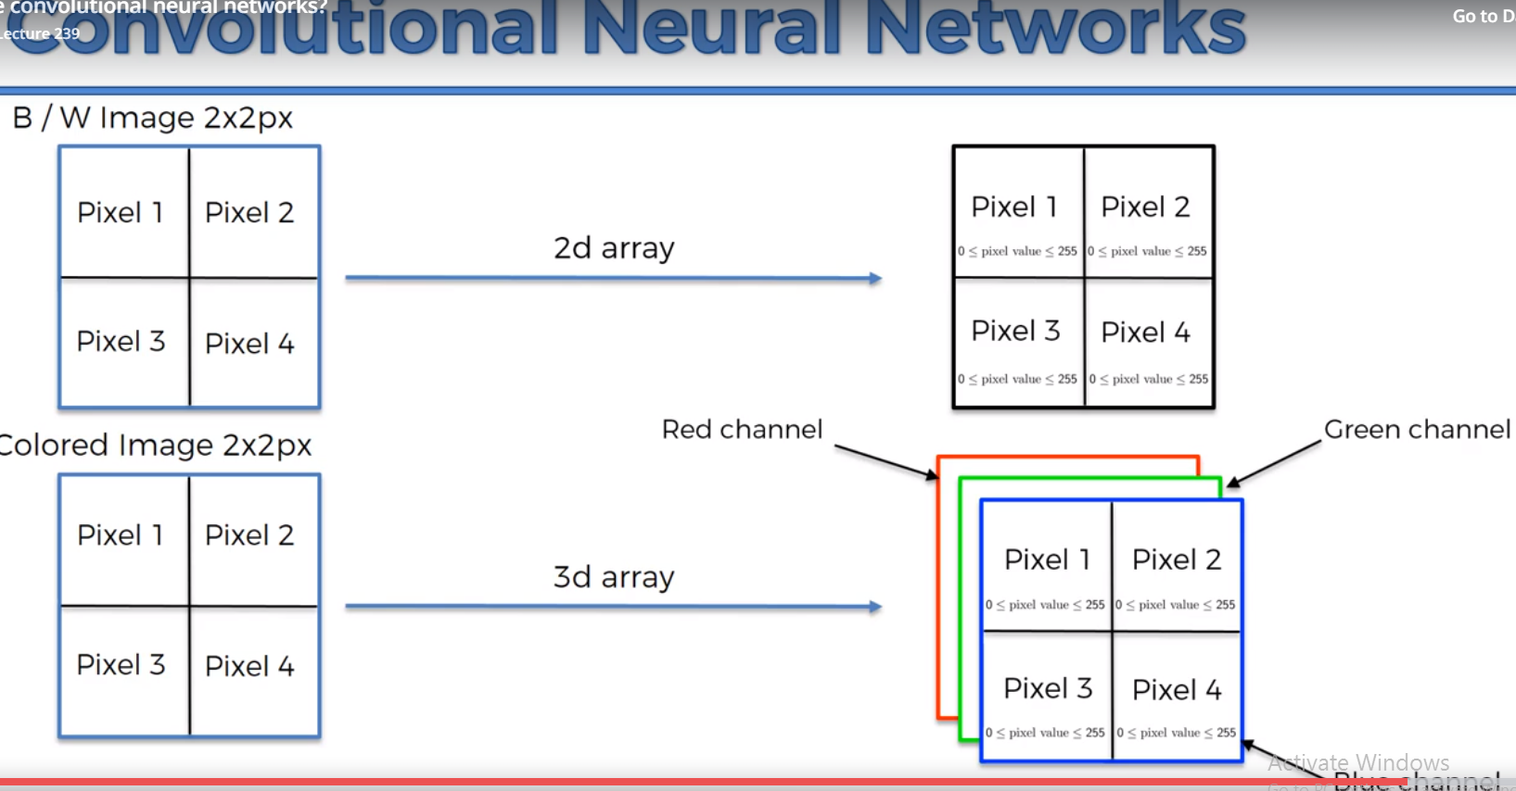

Example:

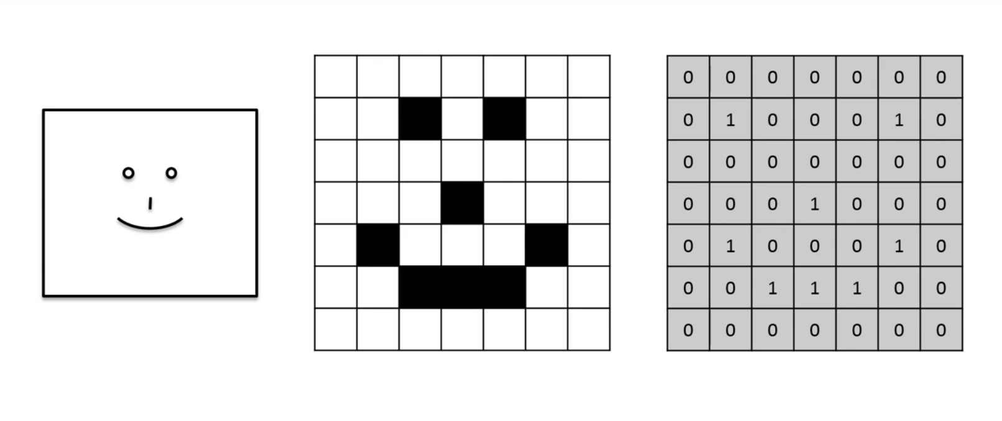

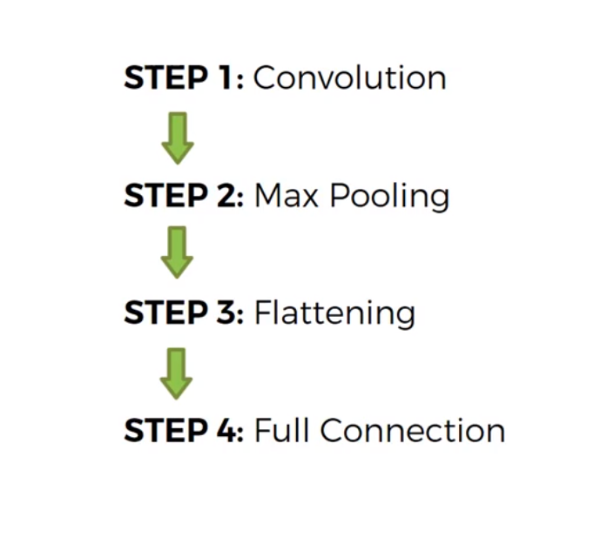

Step 1: Convolution

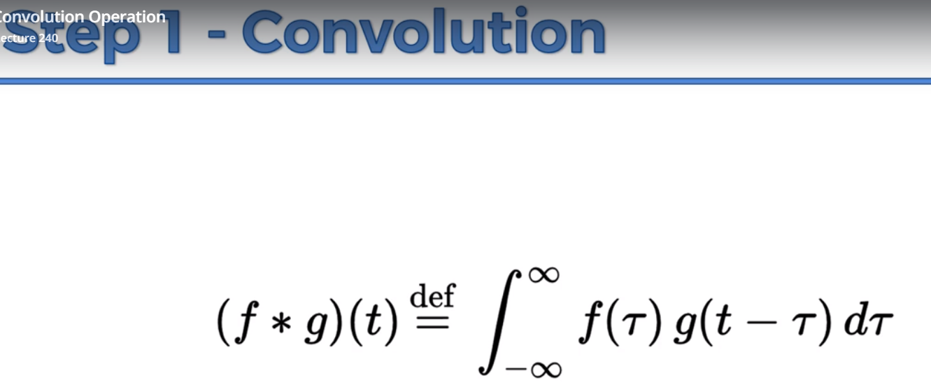

Feature detector is also called as filter or kernel

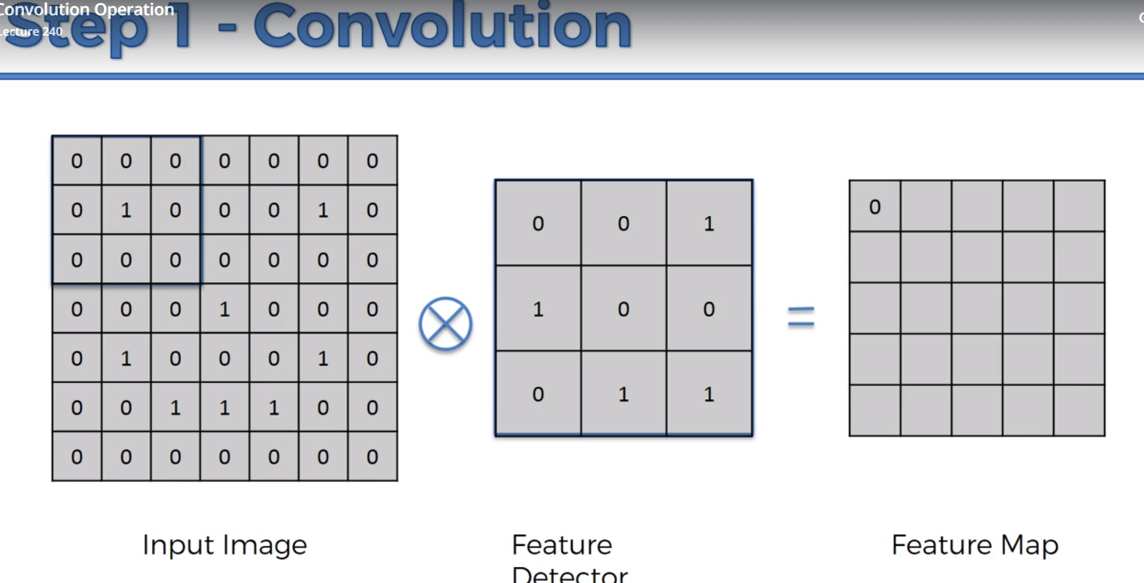

Nothing matched up so 0,

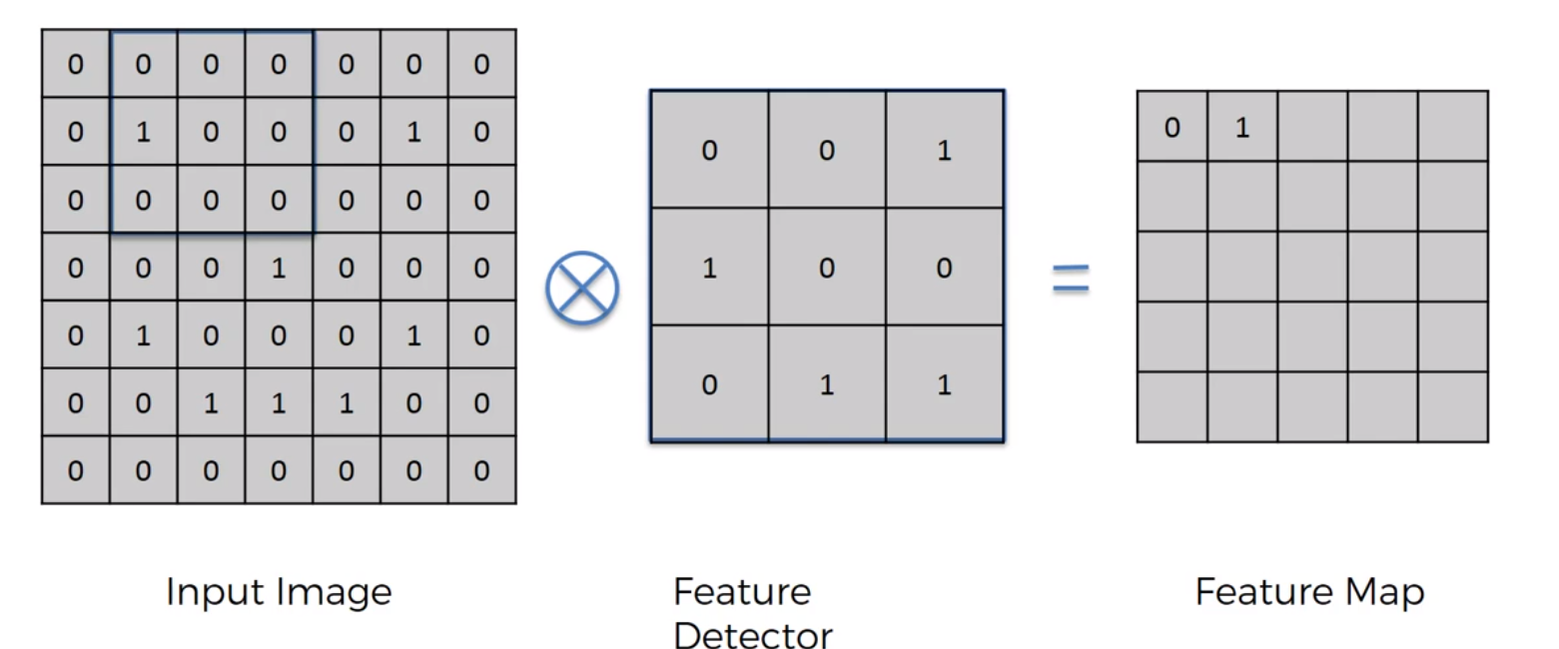

Matching is there hence 1 in feature mapping

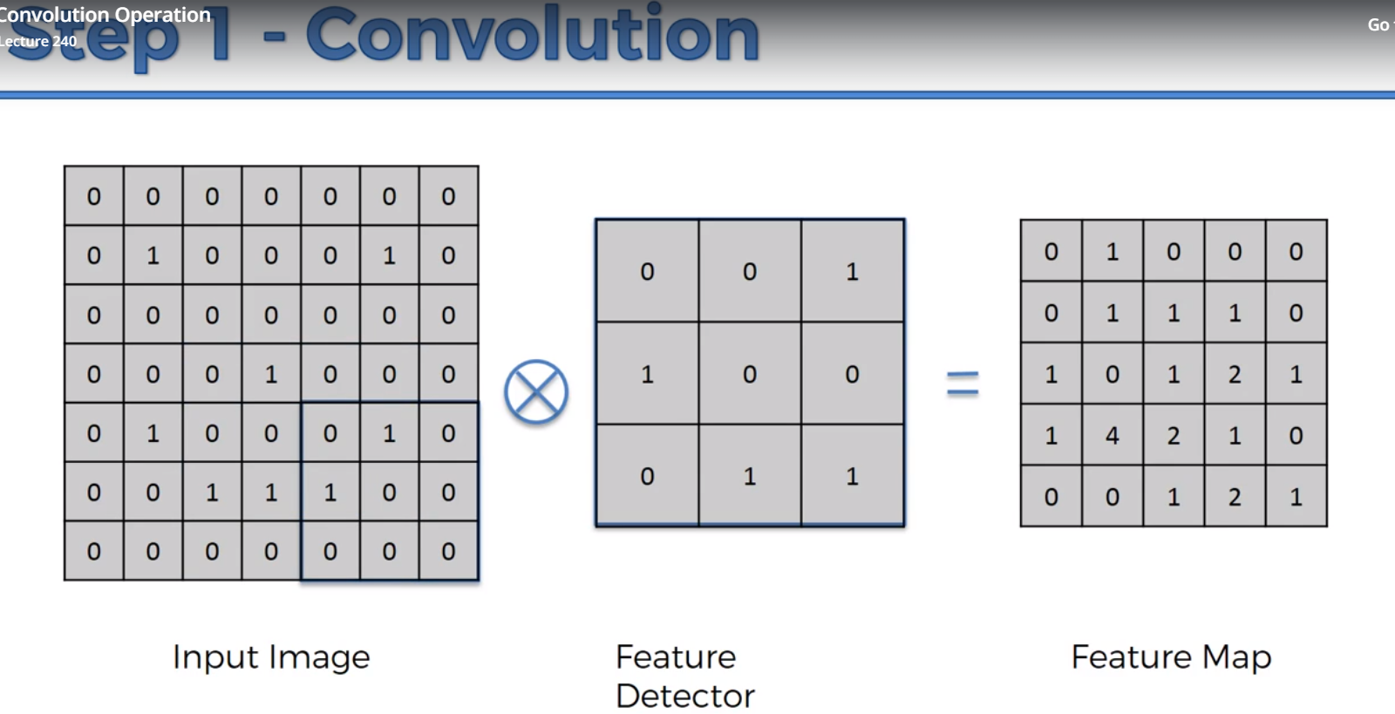

1. Input image size is reduced when compared to feature map using feature detector. It will make it faster.

2. Feature Detector will lose use some info, but that is ok. Every single pixel is not important, the maximum matching is we are looking for(feature mapping helps us on it).

We use multiple feature map to get the convolution layer

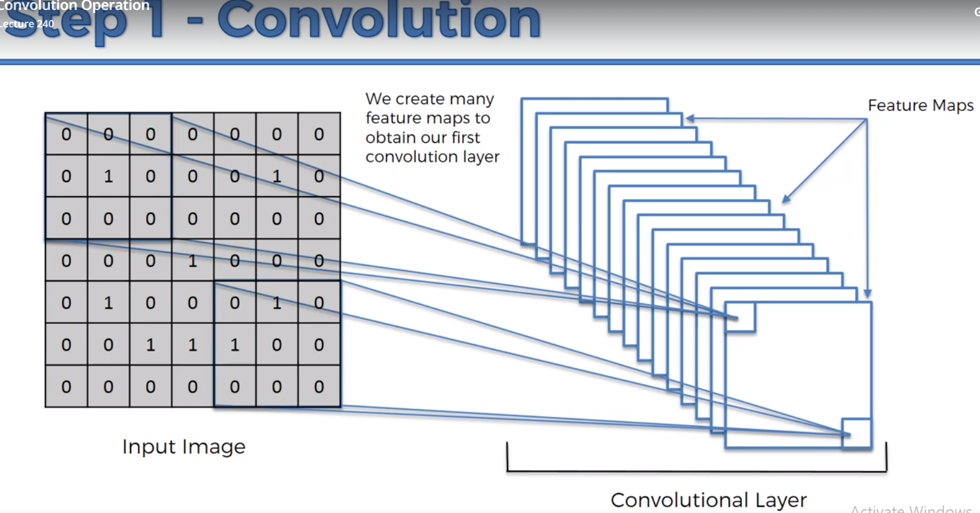

Example:

Sharpen, reduces the pixels around 5

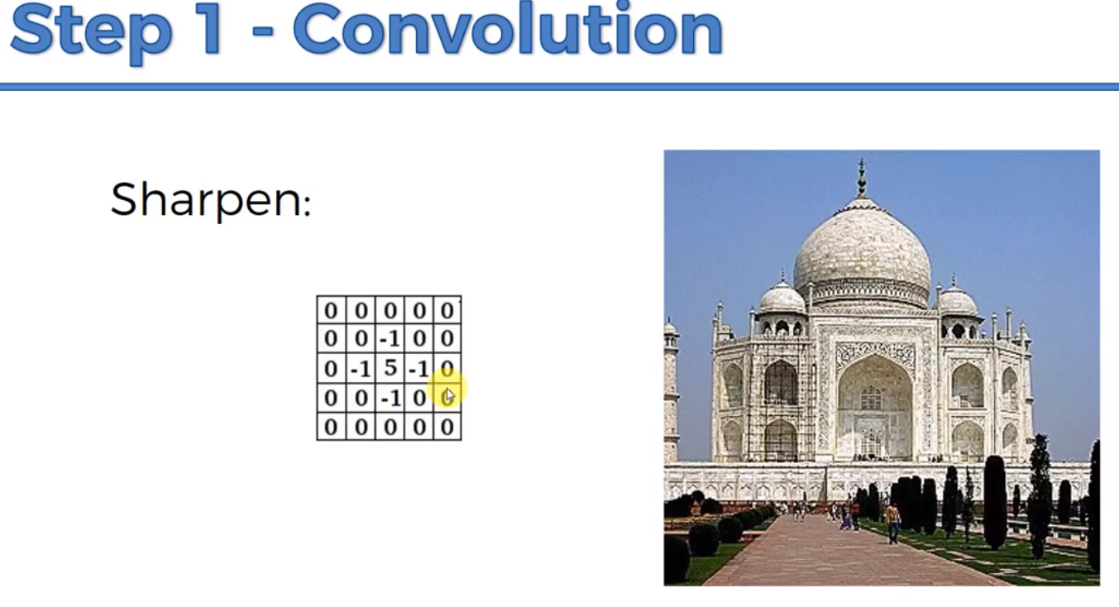

Blur makes it equal significance,

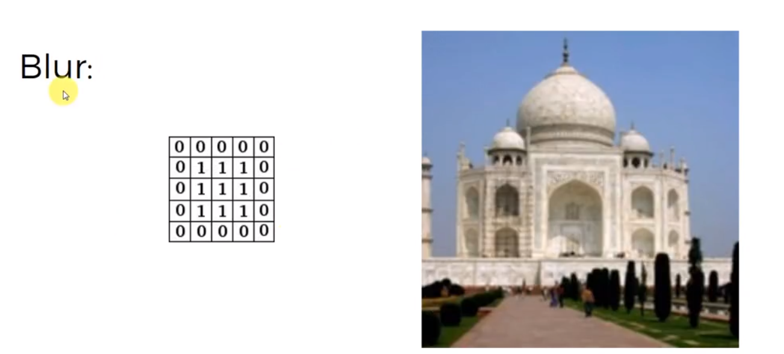

Edge Enhance,

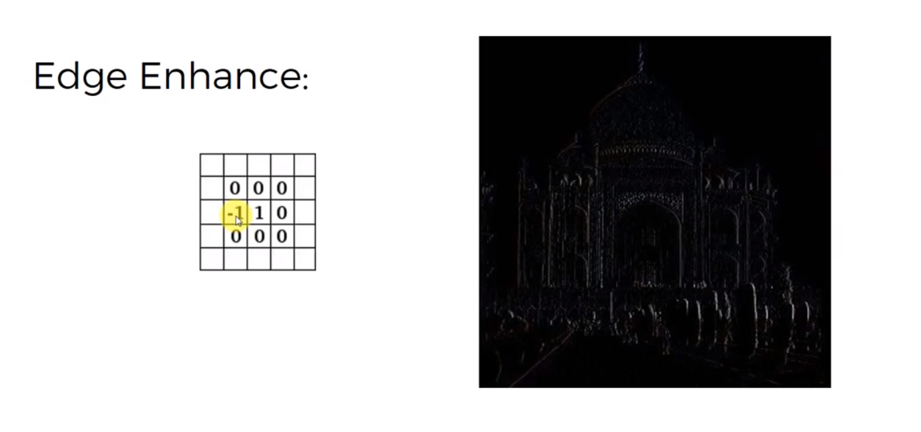

Edge detect is import in CNN,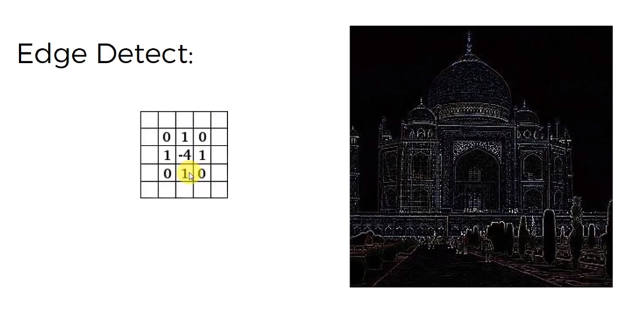

Final Example,

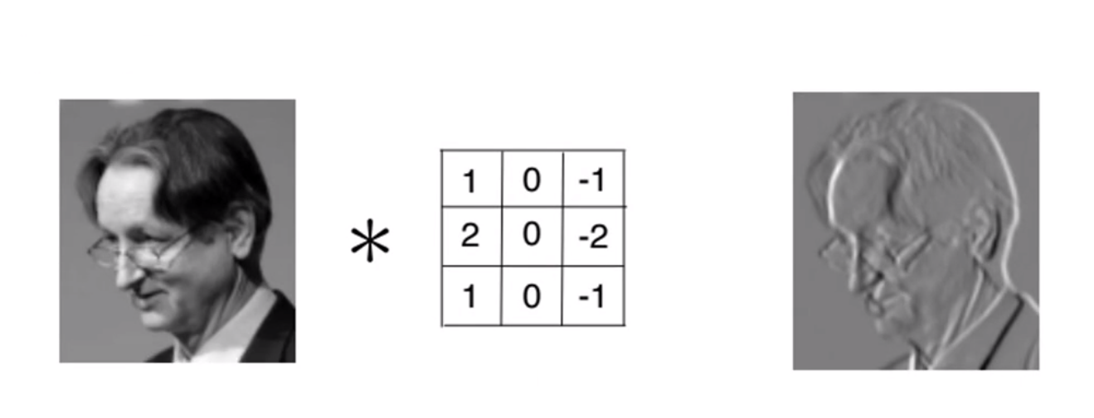

**Step 1(B)- ReLU Layer:**

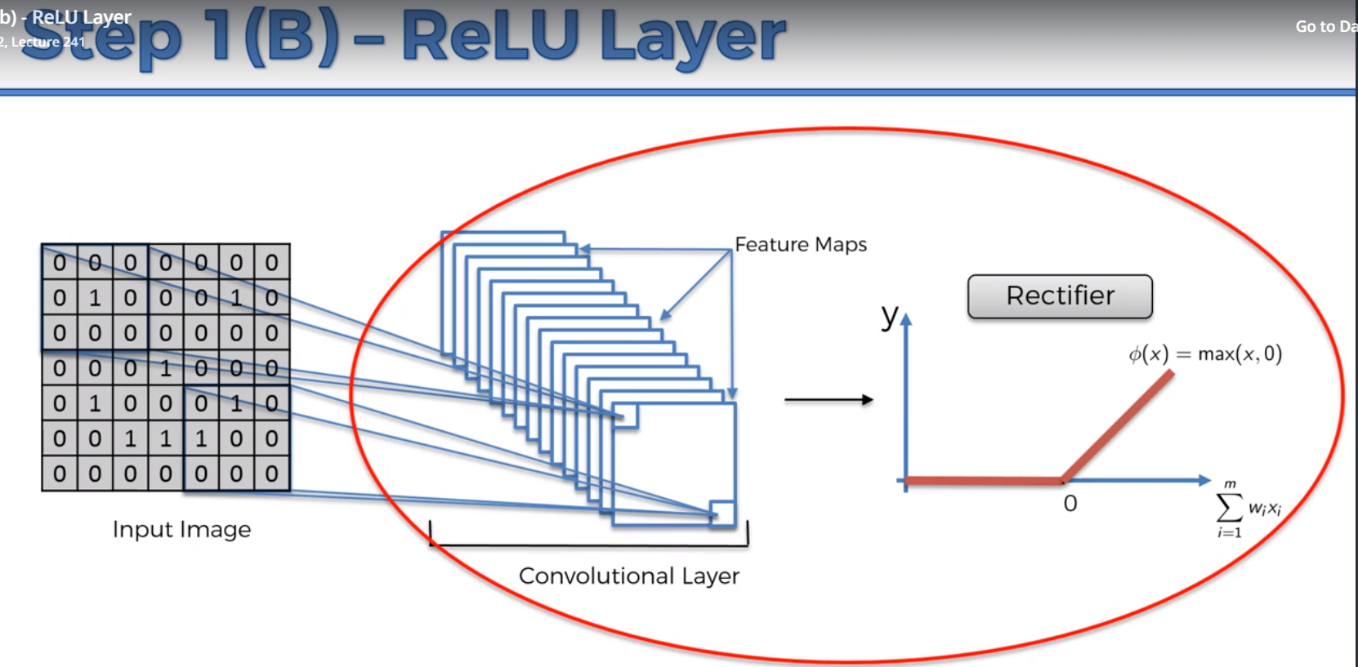

To increase non-linearity because, images are non-linear (border, color).

Let us consider the below image,

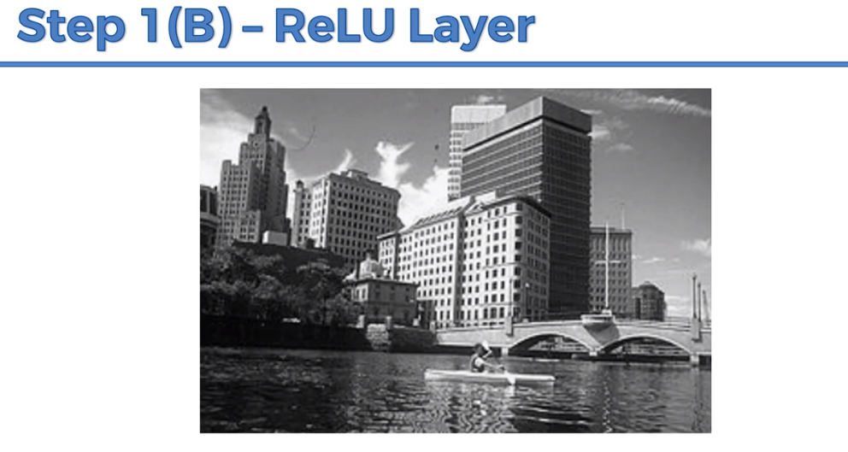

When we apply feature detector(it has pos and neg) then,

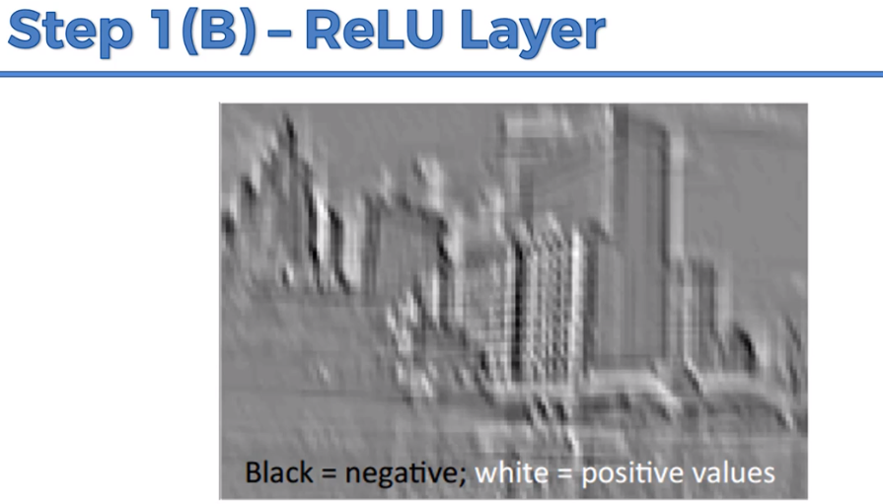

The rectifier will remove all the black and gives, non-negative values,

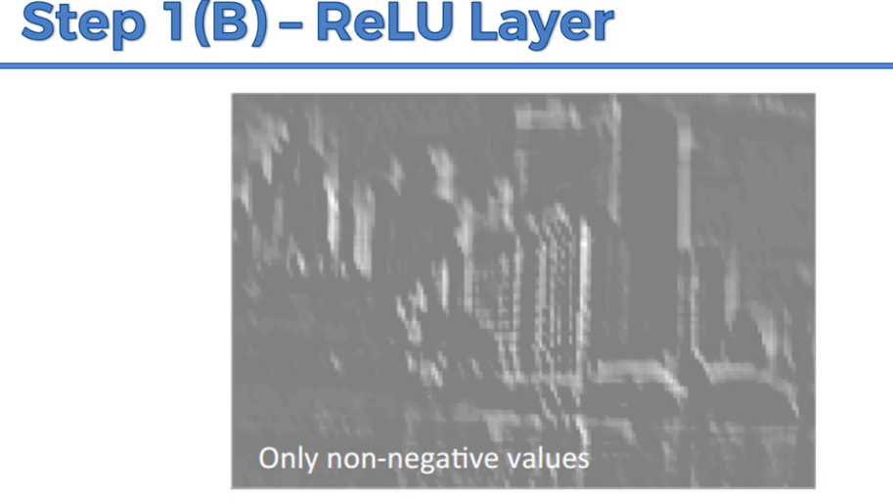

Benefits, it will remove shadows in the building (breaking up the linearity)

Step 2: Max Pooling:

We want the neural network to recognize all the cheetah even though it is rotated

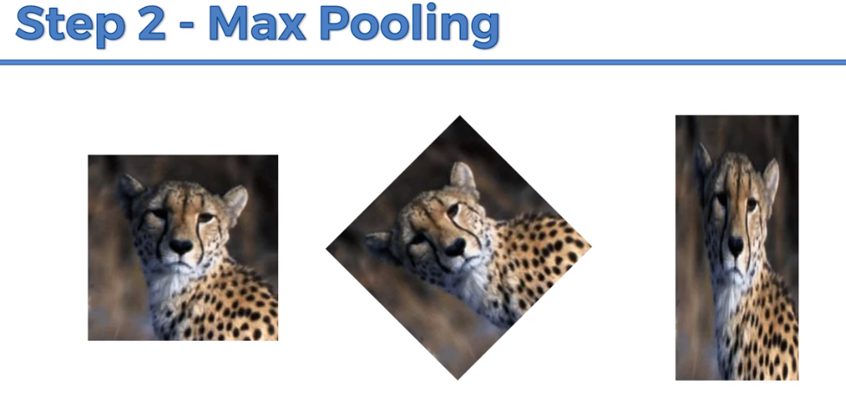

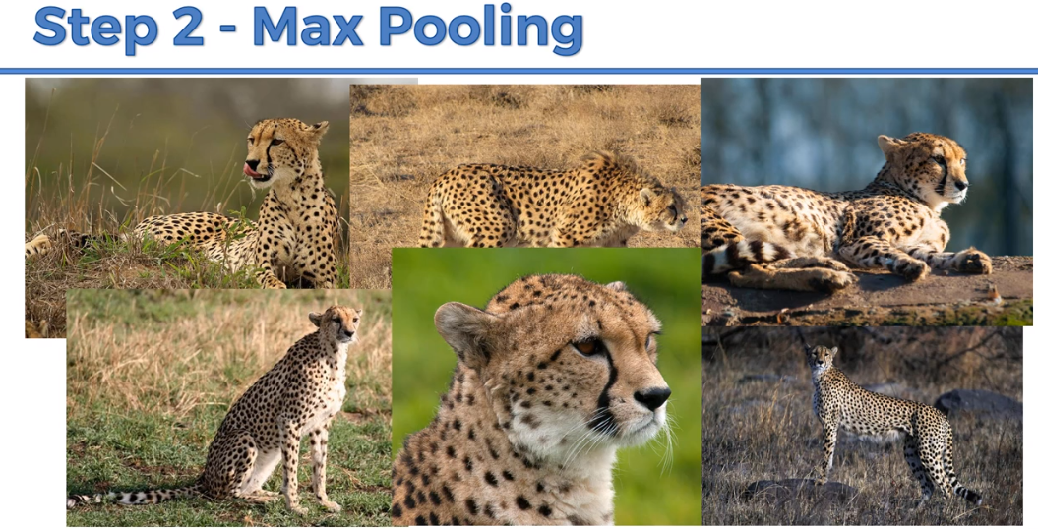

Spatial invariant🡪flexibility to identify the image.

**Types:**

1. min pooling,

2. max pooling

3. sum pooling

Consider a 2*2 matrix and get the maximum value from the feature map.

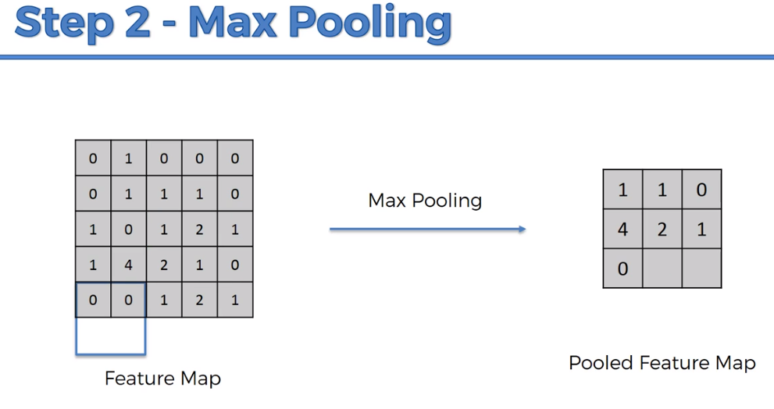

We are preserving the feature ie closest similarity and we removed 75% of the image that might mislead the prediction.

Even though the image is rotated, pooling will able to preserve the feature.

We are reducing the size 75% at the same time preserving the information and reducing the parameter and we can avoid over-fitting.

Sub sampling🡪 avg pooling or mean pooling

Materials: <http://ais.uni-bonn.de/papers/icann2010_maxpool.pdf>

Working application materials: <http://scs.ryerson.ca/~aharley/vis/conv/flat.html>

(it helps in working of CNN. Downsampling is also known as Pooling).

In pooling the same feature with less information and reduced size.

**Step 3-Flattening:**

To be fed as an input as a machine neural network.

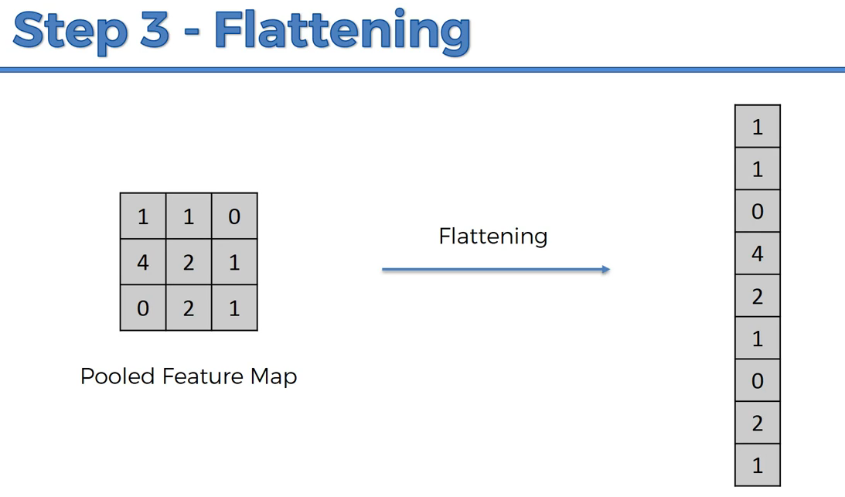

**To summarize,**

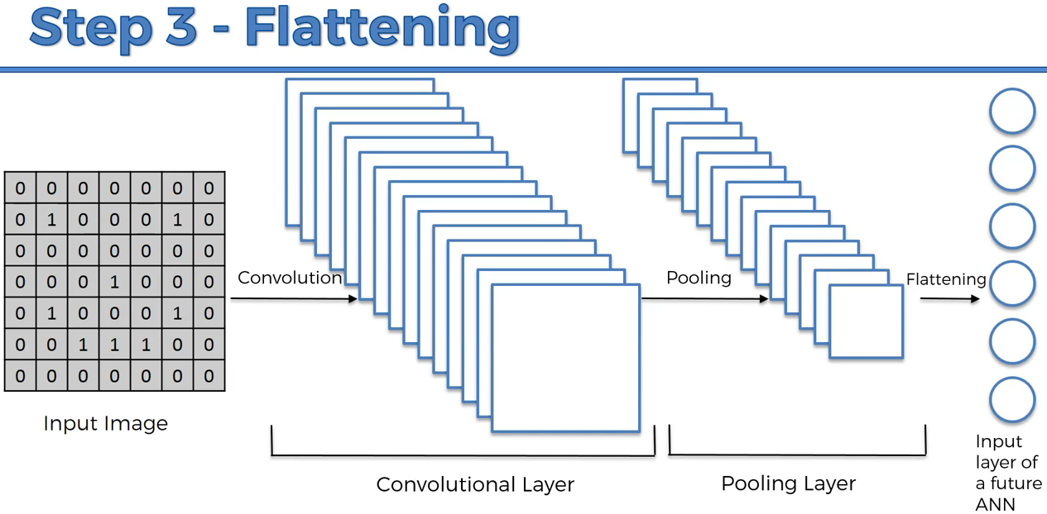

**Step 4: Full Connection**

Fully connected layer is also known as hidden layer.

To predict the class even better.

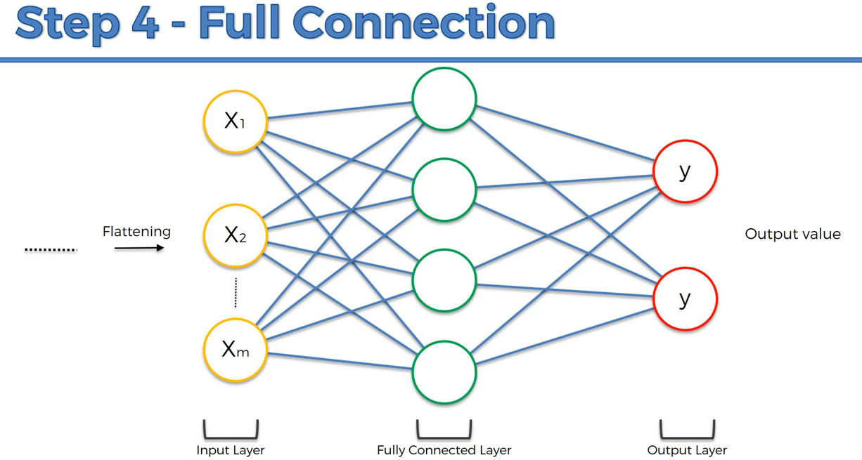

Another Example:

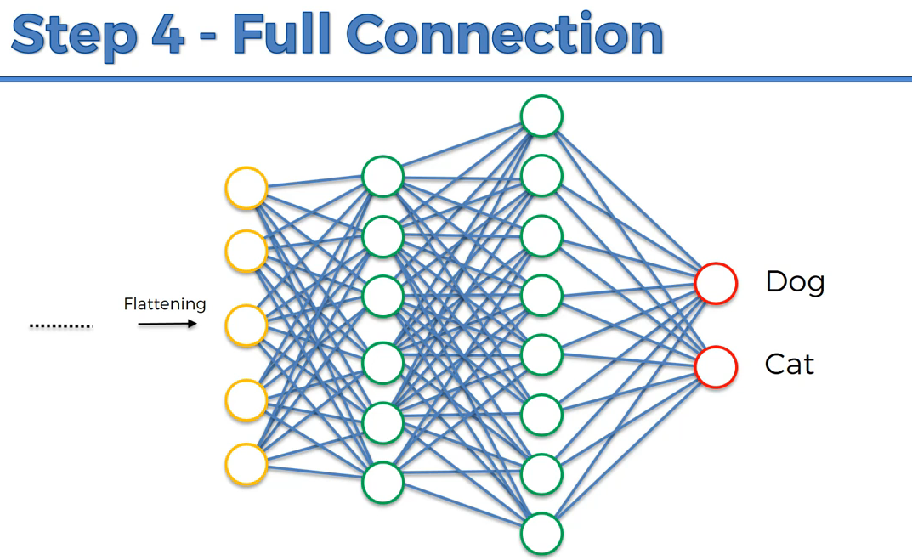

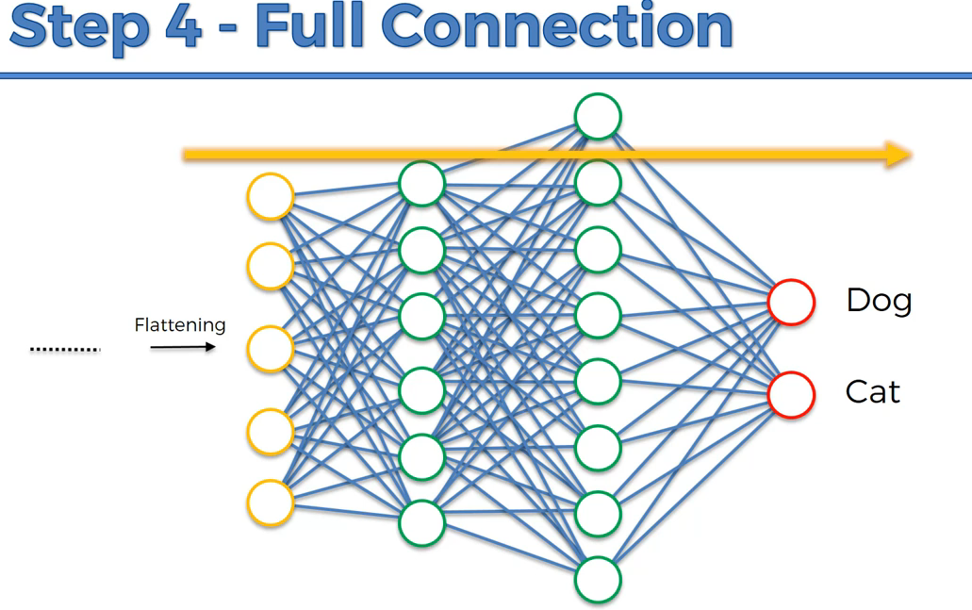

Violent line will send the error and correct the system, so that it will predict well.

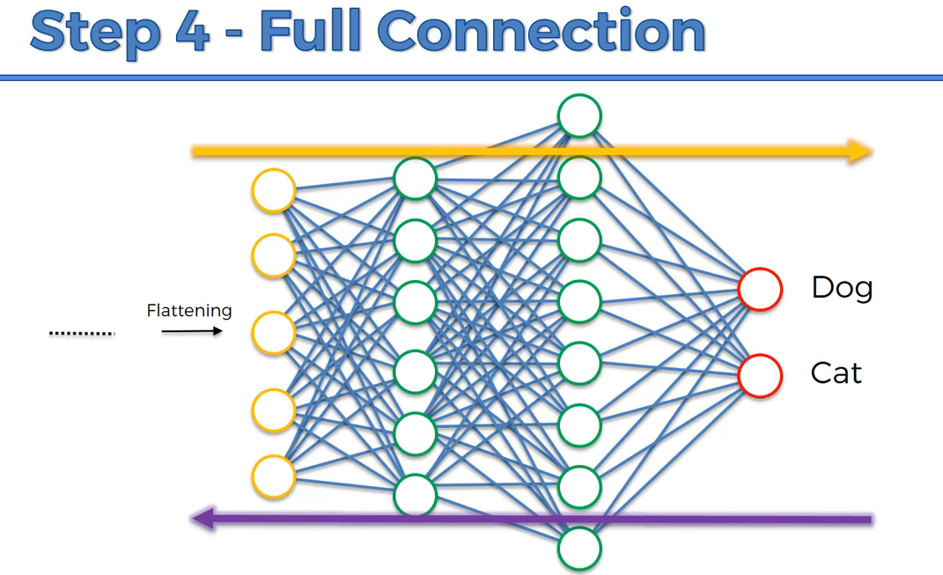

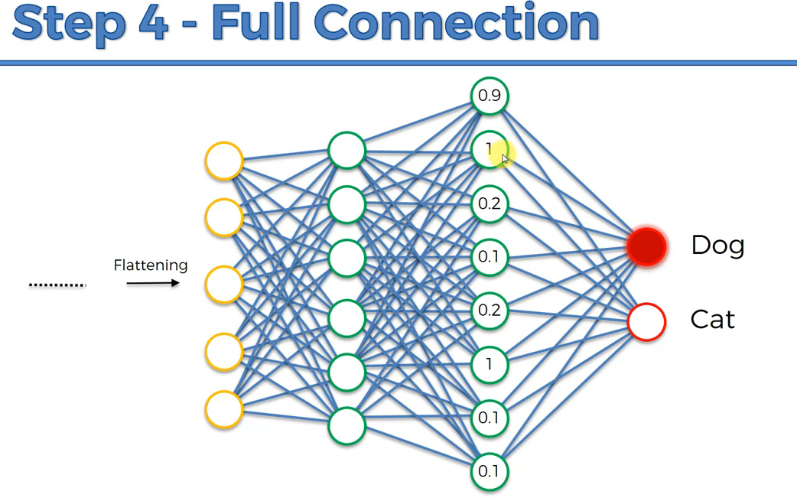

Dog neuron, knows by analyzing the feature neuron. It will give importance to the below highlighted 3 neuron and slightly neglect others.

Eg, fluffy ears, long tail, huge size, big nose.

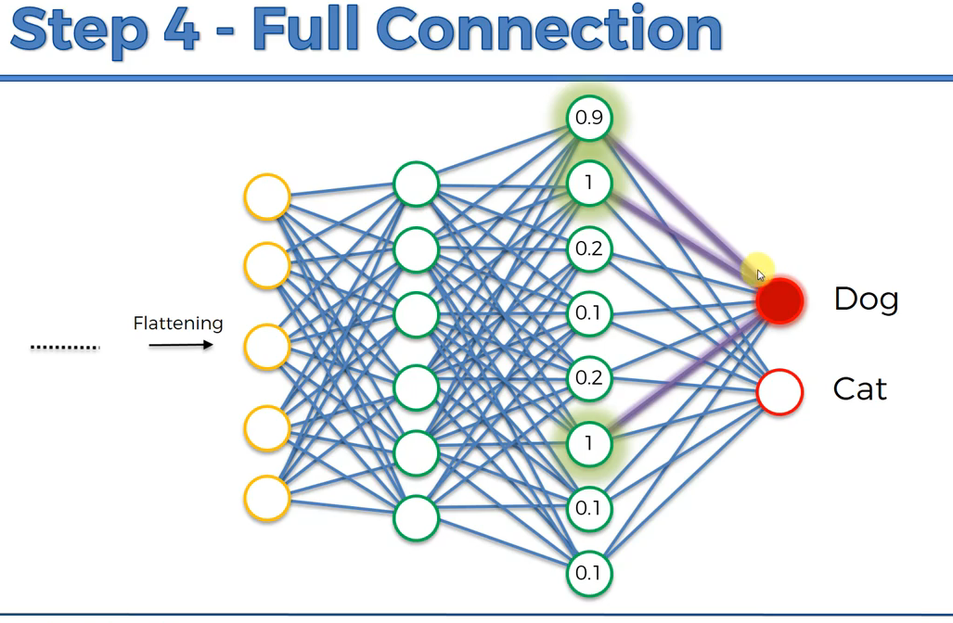

Another example for cat,

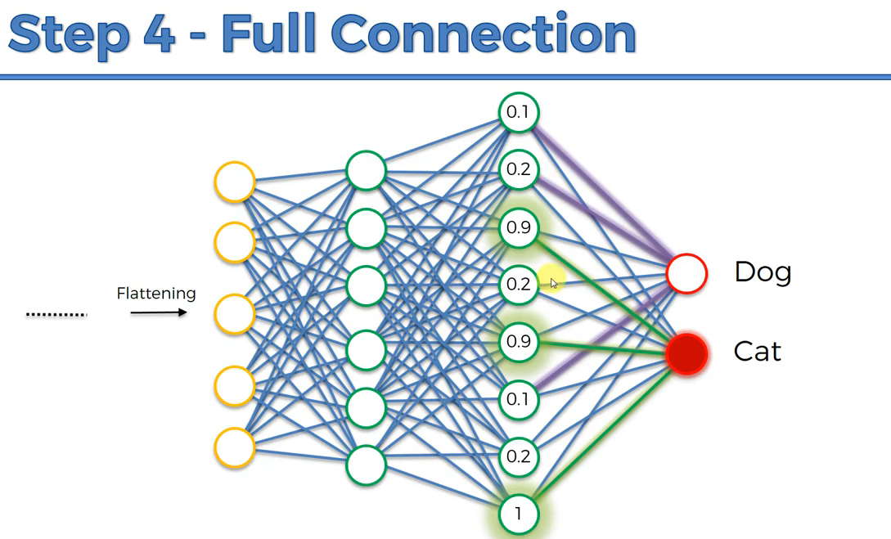

This is how the final neuron will learn from the fully connected layer.

Once the network is trained up,

They will listen to their corresponding neuron related to them.

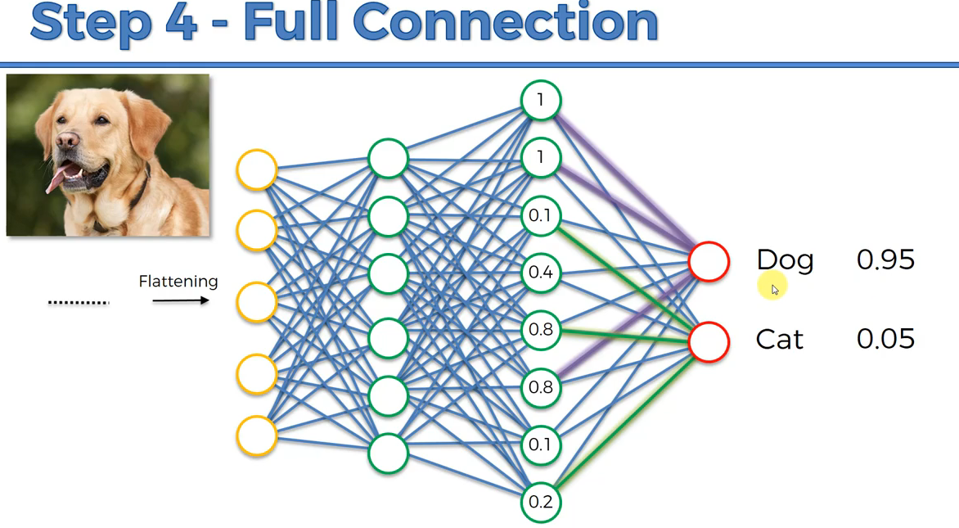

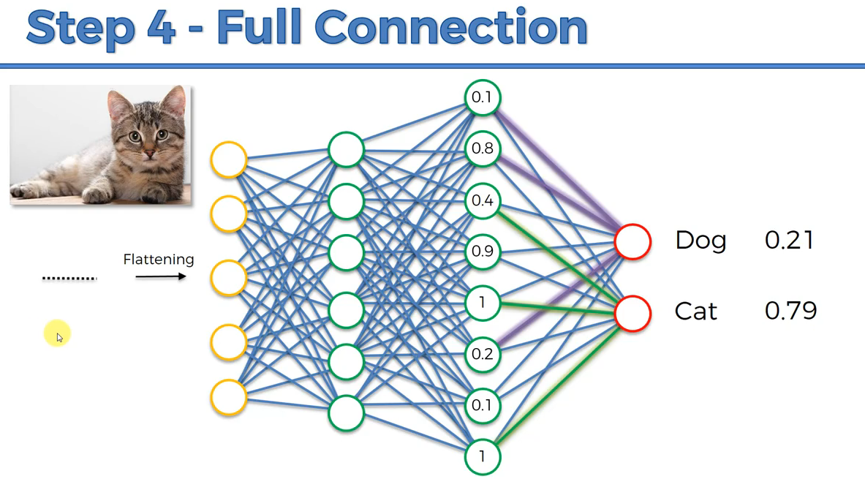

Based on the voting of the feature and weights (purple , green ), the prediction is done by learning in training set.

This is how the prediction works,

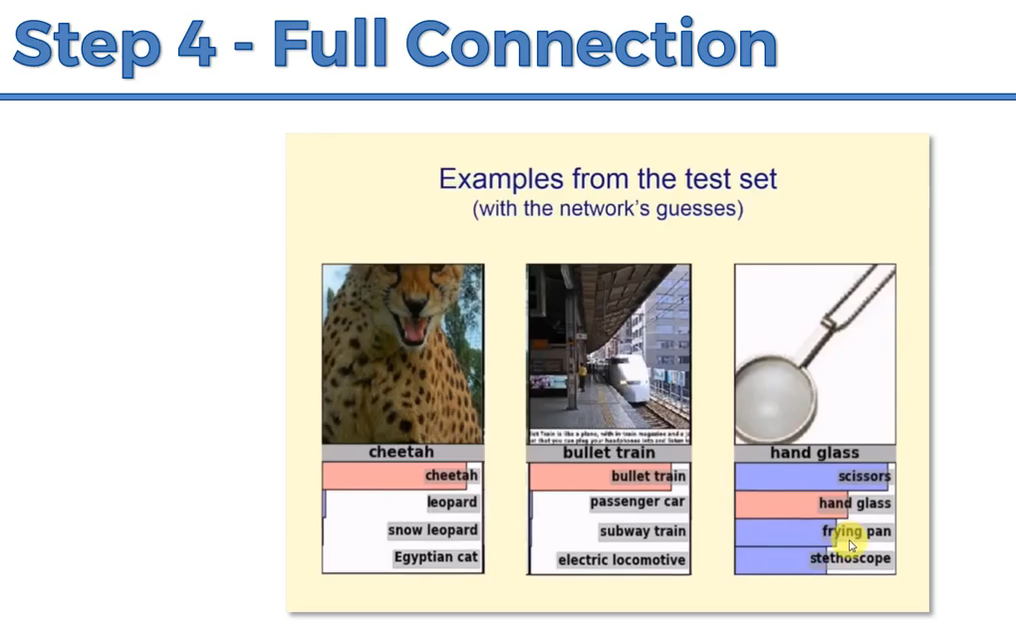

**Summary:**

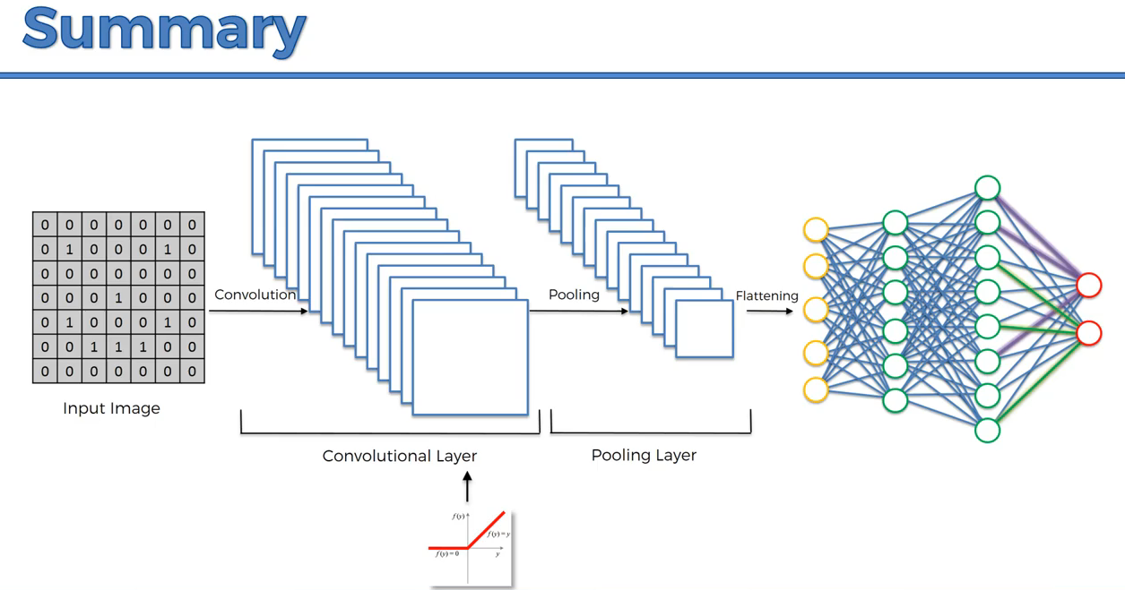

**Important research paper for CNN:**

[**https://adeshpande3.github.io/The-9-Deep-Learning-Papers-You-Need-To-Know-About.html**](https://adeshpande3.github.io/The-9-Deep-Learning-Papers-You-Need-To-Know-About.html)